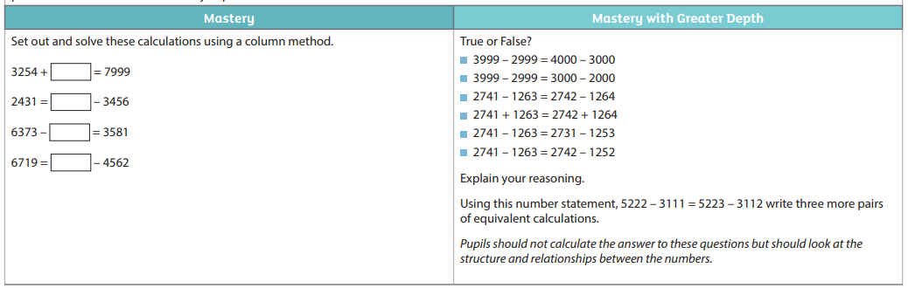
Challenge 1
34 + 24 = 76 + 56 = 321 – 99 =
78 + 21 = 95 – 41 = 872 – 85 =

