Ch.1 Insert modal verbs into the gaps of the sentences below, ensuring each sentence is written in Standard English.
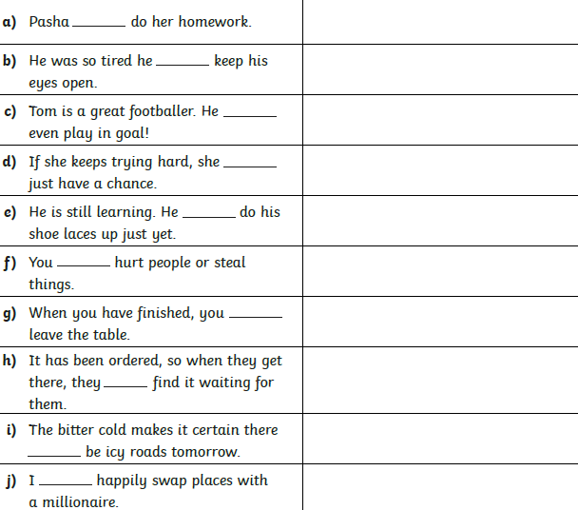
Ch.2 Compose at least 6 of the sentences below into your books. Underneath each sentence write a list of modal verbs that would ensure the sentence is written in Standard English.

