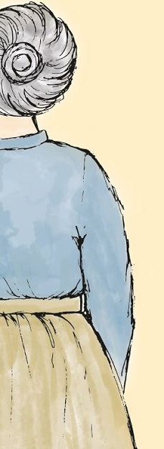 | Grannie  I stayed with her when I was six then went  To live elsewhere when I was eight years old.  For ages I remembered her faint scent  Of lavender, the way she’d never scold  No matter what I’d done, and most of all  The way her smile seemed, somehow, to enfold  My whole world like a warm, protective shawl.  I knew that I was safe when she was near,  She was so tall, so wide, so large, she would  Stand mountainous between me and my fear,  Yet oh, so gentle, and she understood  Every hope and dream I ever had.  She praised me lavishly when I was good,  But never punished me when I was bad.  Years later war broke out and I became  A soldier and was wounded while in France.  Back home in hospital, still very lame,  I realised suddenly that circumstance  Had brought me close to that small town where she  Was living still. And so I seized the chance  To write and ask if she could visit me.  She came. And I still vividly recall  The shock that I received when she appeared  That dark cold day. Huge grannie was so small!  A tiny, frail, old lady. It was weird.  She hobbled through the ward to where I lay  And drew quite close and, hesitating, peered.  And then she smiled: and love lit up the day.

1. Find and copy one word from the first verse that shows that the poet’s grannie made him feel safe when he was a boy.
1 mark

2. How did the poet’s grannie react when he behaved badly?
1 mark

3. The poet describes his grannie as standing mountainous between me and my fear. This makes her sound big and powerful.
What other impressions do you get of his grannie in the same verse?
Give two impressions.
2 marks

4. What was one effect of the poet getting injured in the war?
1 mark

5. Look at the verse beginning: Years later…
Find and copy a group of words that means the same as ‘took the opportunity’.
1 mark

6. What does the poet ask his grannie to do?
1 mark

7. She came. And I still vividly recall…
What do the words vividly recall mean?
2 marks

8. Explain what the poet finds weird about his grannie in the last verse.
2 marks

