Hartsbourne Primary School
Mission statement: Valuing Potential; Creating Opportunities

School Uniform Policy
To be read in conjunction with the following policies: Admissions,Behaviour, Race Equality, Inclusion,, SEND Policies

POLICY REVIEW

DATE OF POLICY: | January 2023 | DATE OF NEXT REVIEW: | January 2025
MONITORED BY: | SENIOR LEADERSHIP TEAM | FULL GOVERNING BODY | 16/03/23

Aims

This policy aims to:
- Set out our approach to requiring a uniform that is of reasonable cost and offers the best value for money for parents and carers
- Explain how we will avoid discrimination in line with our legal duties under the Equality Act 2010
- Clarify our expectations for school uniform

Our school’s legal duties under the Equality Act 2010

The Equality Act 2010 prohibits discrimination against an individual based on the protected characteristics, which include sex, race, religion or belief, and gender reassignment.

To avoid discrimination, our school will:
- Avoid listing uniform items based on sex, to give all pupils the opportunity to wear the uniform they feel most comfortable in or that most reflects their self-identified gender
- Make sure that our uniform costs the same for all pupils
- Allow all pupils to have long hair (though we reserve the right to ask for this to be tied back)
- Allow all pupils to style their hair in the way that is appropriate for school yet makes them feel most comfortable
- Allow pupils to request changes to swimwear for religious reasons
- Allow pupils to wear headscarves and other religious or cultural symbols
- Allow for adaptations to our policy on the grounds of equality by asking pupils or their parents to get in touch with the school – admin@hartsbourne.org.uk, who can answer questions about the policy and respond to any requests

Limiting the cost of school uniform

Our school has a duty to make sure that the uniform we require is affordable, in line with statutory guidance from the Department for Education on the cost of school uniform.

We understand that items with distinctive characteristics (such as branded items, or items that have to have a school logo or a unique fabric/colour/design) cannot be purchased from a wide range of retailers and that requiring many such items limits parents’ ability to ‘shop around’ for a low price.

We will make sure our uniform:
- Is available at a reasonable cost
- Provides the best value for money for parents/carers

We will do this by:
- Carefully considering whether any items with distinctive characteristics are necessary
- Limiting any items with distinctive characteristics where possible, by only asking that the school jumper/cardigan features the school logo
- Keeping the number of optional branded items to a minimum, so that the school’s uniform can act as social leveler
- Avoiding different uniform requirements for extra-curricular activities
- Making sure that arrangements are in place for parents to acquire second-hand uniform items
- Avoiding frequent changes to uniform specifications and minimising the financial impact on parents of any changes
- Consulting with parents and pupils on any proposed significant changes to the uniform policy and carefully considering any complaints about the policy

Expectations for School Uniform

Pale blue sweatshirt
or
Pale blue cardigan
(with school logo)

Royal Blue Fleece
(Optional)l

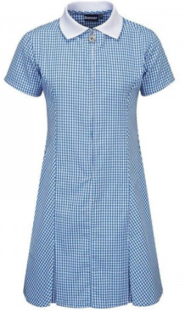  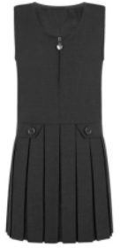  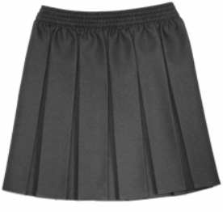  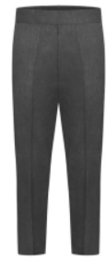 | Grey skirt  Grey pinafore  Grey trousers  Grey shorts  Blue and white gingham check dress for Summer  Children in Nursery Reception are permitted to wear either black or dark grey joggers instead of school trousers

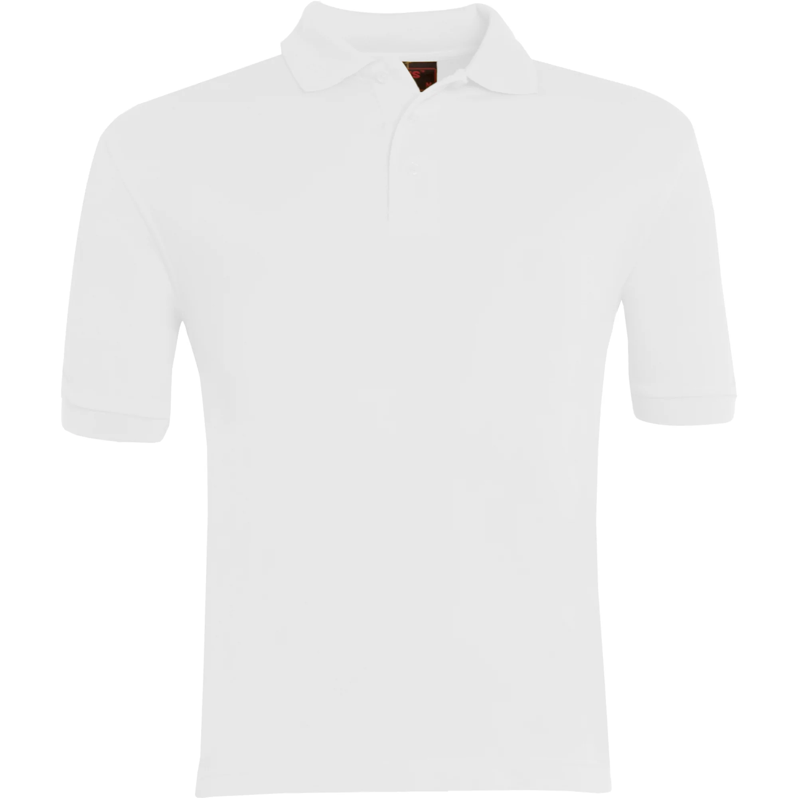 | Plain white polo shirt

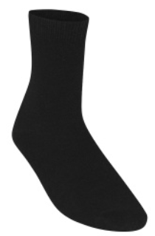  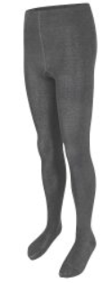 | Grey/black socks  Grey/black tights
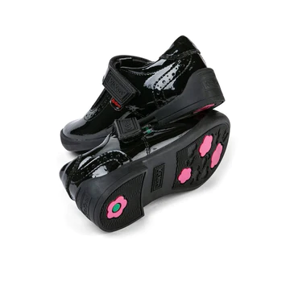
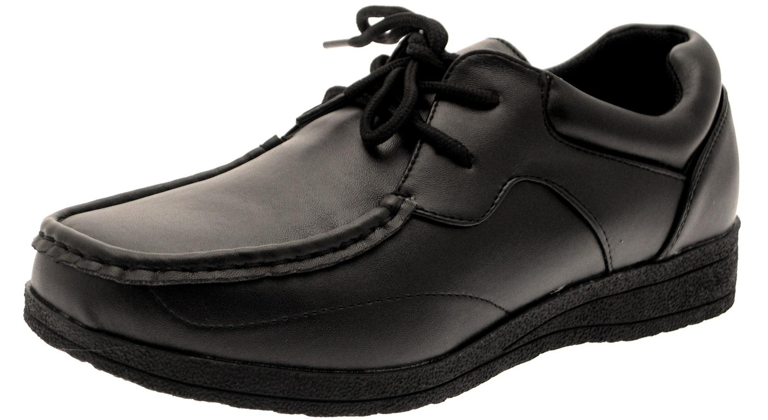 | In order to promote independence, we expect your child to wear appropriate black footwear.  Shoes with easy fastenings such as Velcro are preferred, this will allow your child to put on and take off their shoes independently.  Flip-flops, Uggs, Converse, trainers or Crocs are not part of school uniform.

A book bag and/or a
school bag will enable your child to bring home reading books and home-learning on a regular basis.

A book bag with the school logo is available from https://www.uniform4kids.com/collections/hartsbourne-primary-school

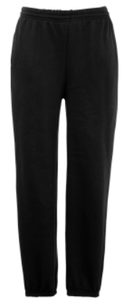  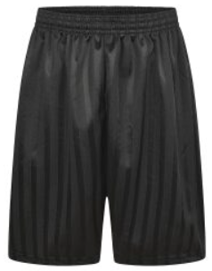 | The PE uniform for all children consists of:  Navy Plain sweatshirt  White plain T shirt (With or without logo)  Navy shorts or jogging bottoms  Black plimsolls or trainers

Swimming Kit (Year 4)
- Swimming costume or swimming shorts
- Towel
- Hat and goggles
- Drawstring bag

Reminders
- Children may wear a simple watch but other jewellery is not suitable for the school day. No smart watches should be worn.
- Children with pierced ears may wear small, plain studs – no hoops
- Children should remove any nail varnish before returning to school
- All hair accessories are to be small, plain and blue or white

Where to Purchase It
Branded school uniform items can be purchased from Pullens, 48 – 50 Church Road, Stanmore HA7 4AH
Phone number – 020 8954 3850
Website -https://www.uniform4kids.com/collections/hartsbourne-primary-school
All other school uniform can be bought from more widely e.g. from ‘high-street’ retailers of your choice. The school will organise second hand uniform donations at the end of every term. More information will be provided termly.

Expectations for our School Community

Pupils
Pupils are expected to wear the correct uniform at all times (other than specified non-school uniform days) whilst:
- On the school premises
- Travelling to and from school
- At out-of-school events or on trips that are organised by the school, or where they are representing the school (if required)

Parents and Carers
Parents and carers are expected to make sure their child has the correct uniform and PE kit, and that every item is:
- Clean
- Clearly labelled with their child’s name
- In good condition

Parents are also expected to contact Mrs. Danni Harte if they want to request an amendment to the uniform policy in relation to:
- Their child’s protected characteristics
- The cost of the uniform

Parents are expected to lodge any complaints or objections relating to the school uniform in a timely and reasonable manner. Disputes about the cost of the school uniform will be:
- Resolved locally
- Dealt with in accordance with our school’s complaints policy
The school will work closely with parents to arrive at a mutually acceptable outcome.

Staff
Staff will closely monitor pupils to make sure they are in the correct uniform. They will give any pupils and families breaching the uniform policy the opportunity to comply, but will follow up with the headteacher if the situation does not improve. Ongoing breaches of our uniform policy will be dealt with by Mrs. Danni Harte.

In cases where it is suspected that financial hardship has resulted in a pupil not complying with this uniform policy, staff will take a mindful and considerate approach to resolving the situation

