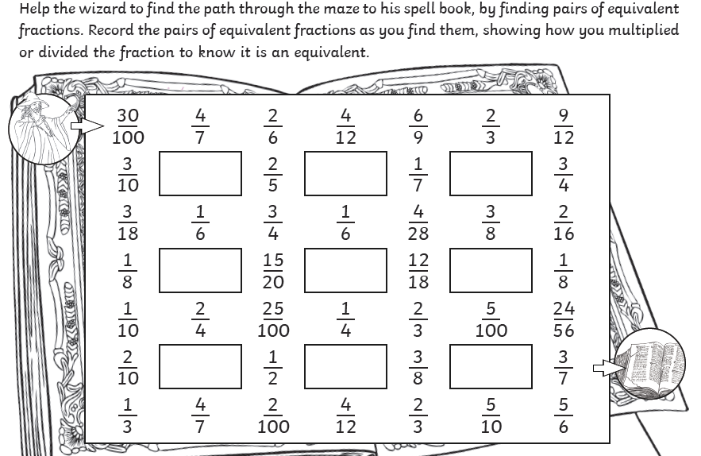

If this is too difficult you can identify equivalent fractions from the selection above and record these in your book.
e.g. ½ = 5/10

