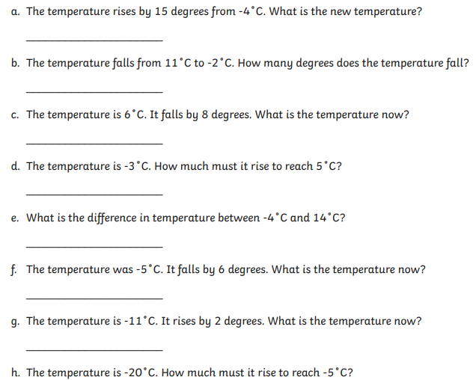
For at least one of the questions, show your working using a number line.

