Q1.
Lifeboats
Lifeboats are strong boats specially built for rescuing people at sea. When they are not in use they are kept at various lifeboat stations all round our coast.
There are two main types of lifeboats.
In-shore lifeboats
These lifeboats rescue people in difficulties close to the shore – for example a swimmer in trouble or someone cut off by the tide. In- shore lifeboats are inflatable boats with outboard engines. They are used instead of the larger boats when help is needed quickly.
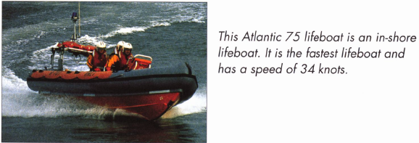
All-weather lifeboats
All-weather lifeboats are used for rescuing people further from shore. They are larger, stronger boats, able to work in deep water and extremely rough weather conditions.
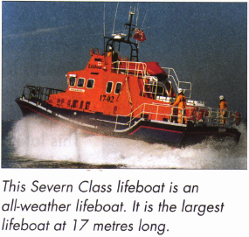
How are lifeboats launched?
Lifeboats are launched in different ways.
Some boats are in the water and so can set off immediately.
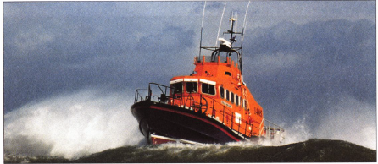
Some are launched from the beach, on a trailer.
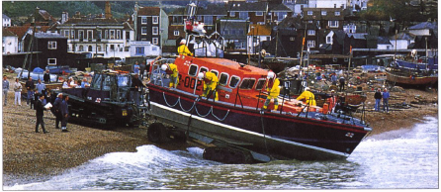
Others run down a special ramp called a slipway.
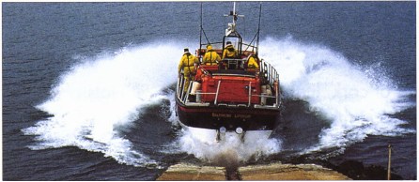
Who invented the lifeboat?
The first real lifeboat was built in 1790. It was called the Original and was built by a man called Henry Greathead.
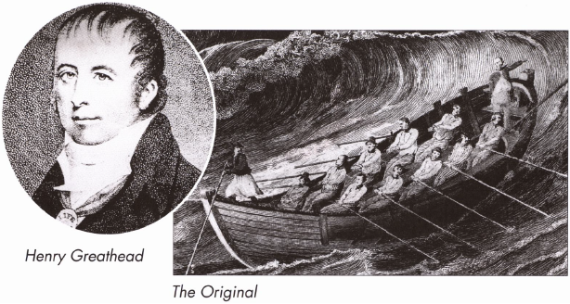
Lifeboats have to sail in very rough seas so it is important that they are as unsinkable as possible.
Henry Greathead used cork to fill the boat’s bow and stern and help keep it afloat. The Original was powered by oars and could be rowed in either direction. It had a crew of 12 men and saved hundreds of lives during the 40 years it was in service.
Nowadays instead of cork, lifeboats are made with lots of watertight air spaces in them. The air in the spaces helps to keep the boat afloat even when there is water flooding the deck.
Lifeboats are self-righting, which means that if they turn over they roll back upright again.
The Royal National Lifeboat Institution (RNLI)
In 1824 an organisation was set up to run all lifeboat stations and build new ones. This became known as the Royal National Lifeboat Institution (RNLI).
Their symbol is a flag showing the red cross of St George.
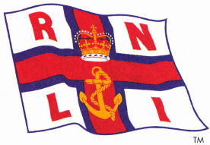
There are now over 200 lifeboat stations around the coast. Lifeboats of Britain are paid for by money that people give to the RNLI.
This lifeboat is called the Blue Peter 7. It was paid for by money given by Blue Peter viewers in 1994.
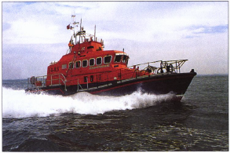
The crews of the lifeboats are unpaid volunteers. They could be teachers, fishermen, shopkeepers, nurses or builders. They all have other jobs but are willing to spend a lot of their spare time being trained.
They risk their lives at sea to save others. Rescuing people by lifeboat is still very dangerous and there have been terrible disasters.
Clothes for the crew
In 1854 a cork lifejacket was invented which gave lifeboat crew weather protection as well as keeping them afloat.
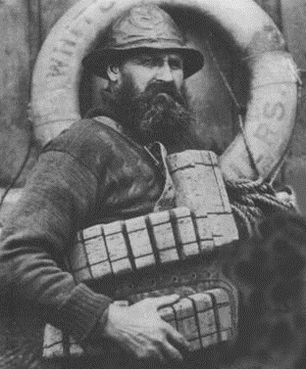
Lifeboat crews need comfortable, waterproof clothing. Their jackets and trousers are specially designed to keep out the wet and wind.
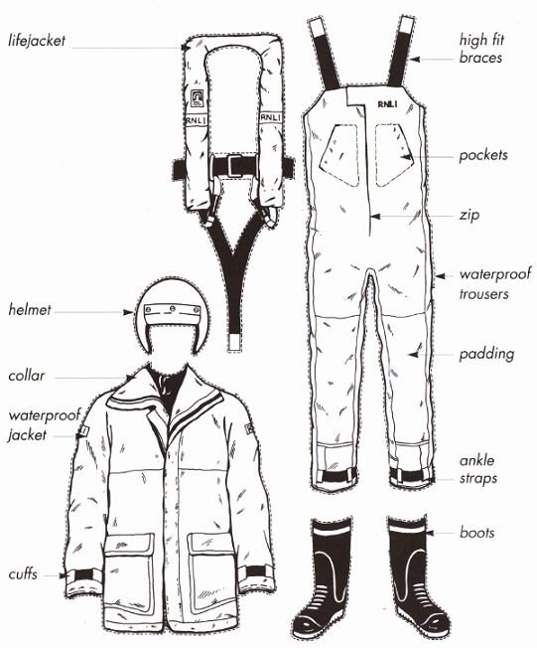

Q2.
Lifeboats
(page 1)
1 Where are the lifeboats kept when not in use?
______________________________________________________________
(page 1)
2 Where do in-shore lifeboats rescue people who are in difficulties?
Tick one.

close to the shore |  | a long way off-shore
in the middle of the ocean |  | in the town
(page 2)
3 Write down two ways in which lifeboats can be launched.
1. ____________________________________________________________
2. ____________________________________________________________
(page 3)
4 How was the Original powered?
Tick one.

by steam |  | by rail
by oars |  | by engine
(page 3)
5 What helped the Original to keep afloat?
______________________________________________________________
(page 3)
6 What helps lifeboats keep afloat now?
Tick one.

They are filled with cork. |  | They go faster.
They have watertight air spaces. |  | They have smaller crews.
(page 4)
7 How are lifeboats paid for?
______________________________________________________________
______________________________________________________________
(page 4)
8 Which one of these words means people who work without being paid?
Tick one.

unsinkable |  | volunteers
upright |  | organisation
(pages 1 - 4)

9 Draw lines to show which lifeboat is which.
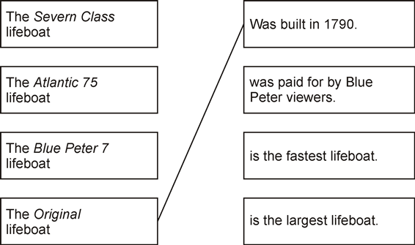
(page 5)
10 A lifejacket was invented in 1854. What was it made from?
______________________________________________________________
(page 6)
11 The crew of the Original lifeboat did not wear any special clothes to carry out their rescue.
Write down three of the clothes worn by modern lifeboat crews that the Original lifeboat crew would have found useful.
1. ____________________________________________________________
2. ____________________________________________________________
3. ____________________________________________________________

