D&T Intended Outcomes
The children have been making these different linkages and levers during lessons. They have used split pins to create pivots. We have designed backgrounds and dragons, as well as deciding which linkage (from the 4 below) we wanted to make.
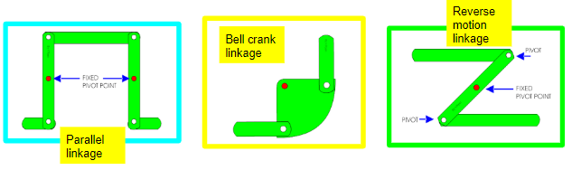
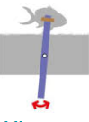
We were aiming to make scenes with dragons with these linkages/levers, inspired by examples below:
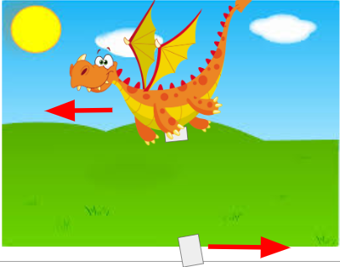
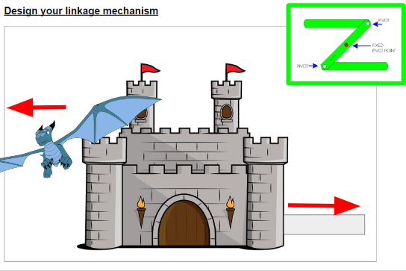
Please can children create their own image which include linkages and levers.

