Lesson 1:
WALT: Explore India’s culture and its influence on other countries.
Read the information below about Indian culture and answer the questions in full sentences:
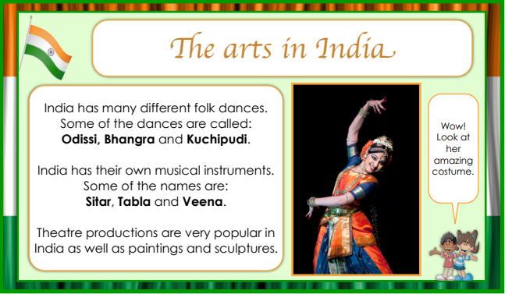
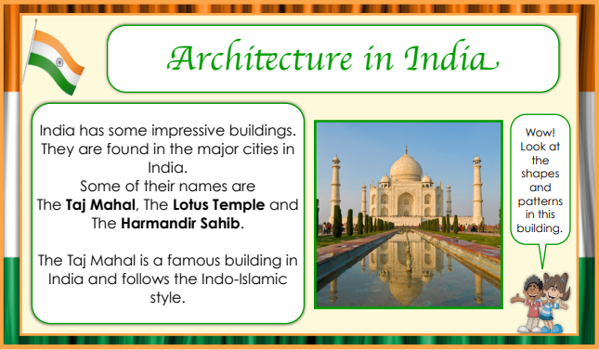
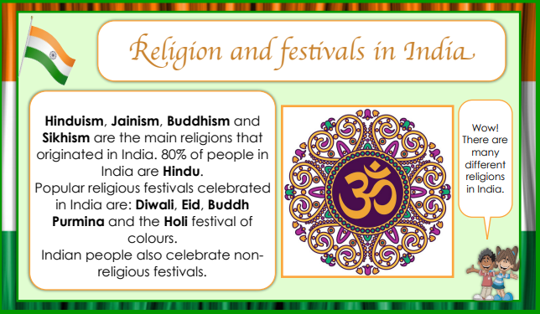
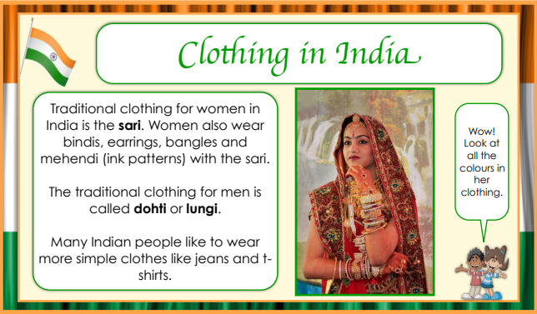
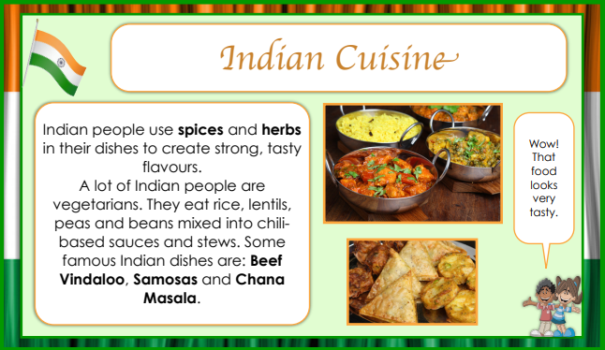
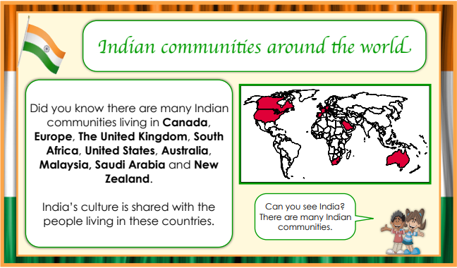

1. What is the name of a traditional Indian dance?
2. What is the name of a famous building in India?
3. What is the name of a festival in India?
4. What is a non-Indian festival celebrated in India?
5. The traditional clothing for Indian women is called...
6. The traditional clothing for Indian men is called...
7. What are the four main religions in India?
8. What is the most common religion in India?
9. Name two Indian dishes you know about.
10. Name two countries Indian people have moved to.

Lesson 2:
WALT: Compare the United Kingdom and India
Compare the United Kingdom and India. Either cut out or write these statements under the correct headings: India or UK.


