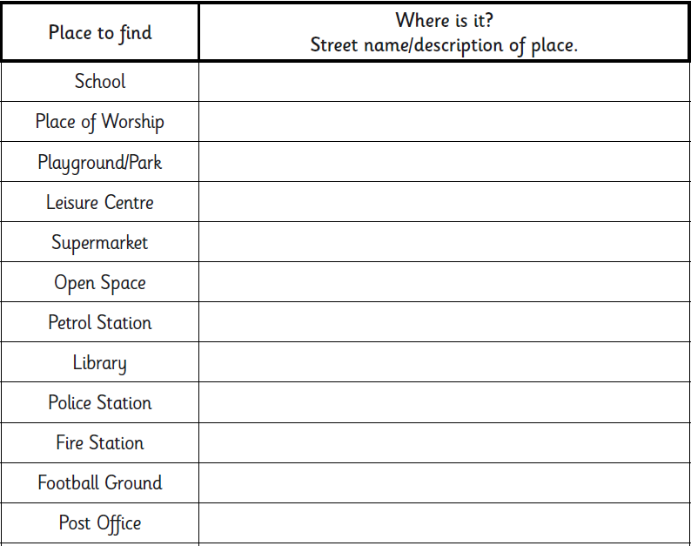
Using Google Maps, find these places in our area?

