WALT: Identify a significant person of local interest.
Label the aeroplanes below.
- 2.
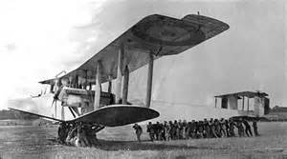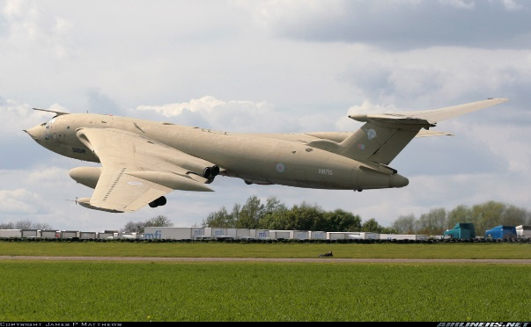

______________________________ _________________________________
3.
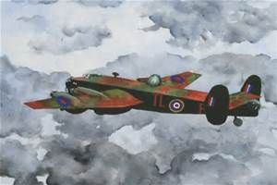
___________________________________

Put the aircraft in order from the oldest to newest.
- _____________________________

- _____________________________

- _____________________________
What is the name of the aircraft company that made these aeroplanes? _______________________________________________________________
Handley Page Victor Handley Page O/100 Handley Page Halifax

