- Calculate :
35x3=105
28x4=112
46x2=92
15x5=75
28x4=112
47x2=94
29x2=58
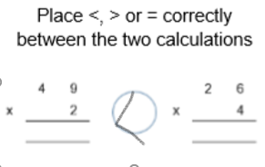
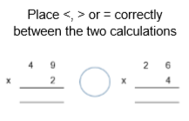
27x3=81
2.

3. Find as many calculations as possible that will result in regrouping of 20 ones for 2 tens or 80 ones for 8 tens.
14x5, 24x5,…
15x5, 25x5, 35x5,…
16x4, 26x4,…
17x3, 27x3,..
17x4, 27x4,..
18x3, 28x3,..
19x3, 29x3,…

