- Calculate :
35x3=
28x4=
46x2=
15x5=
28x4=
47x2=
29x2=
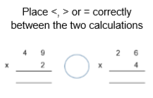
27x3=
2.

3. Find as many calculations as possible that will result in regrouping of 20 ones for 2 tens or 80 ones for 8 tens.

