Using recording frame step 1, record unto part whole model and place value charts and calculate:
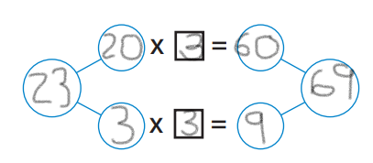
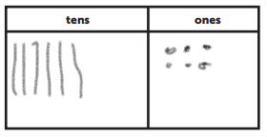
23x3=69

43x2=86
34x2=68
31x3=93
13x3=39
31x2=62

