Challenge 1
Using base-10 drawings and part whole (cherry) model, calculate:
35x2=70
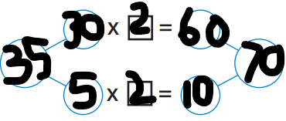
28x4=112
37x3=111
73x3=219
84x2=168
65x3=195
37x5=185
88x3=264
Challenge 2
Compare the products using the equals and inequality symbols:
45x6 and 64x5 270 ‹ 320
38x5 and 58x3 190 › 174
82x3 and 83x2 246 › 166
Challenge 3
Using the digit cards 4, 6, 0, 5 and 2, make two-digit multiplied by one-digit calculations with products that match the following rules: 1. Greatest product with a five in the ones place.
65x5=325
2. Smallest product with a zero in the ones place.
20x2=40

Pupils could explore other ways of distributing the numbers. For example, with 14 x 7, the 14 could be regrouped into 8 and 6.

