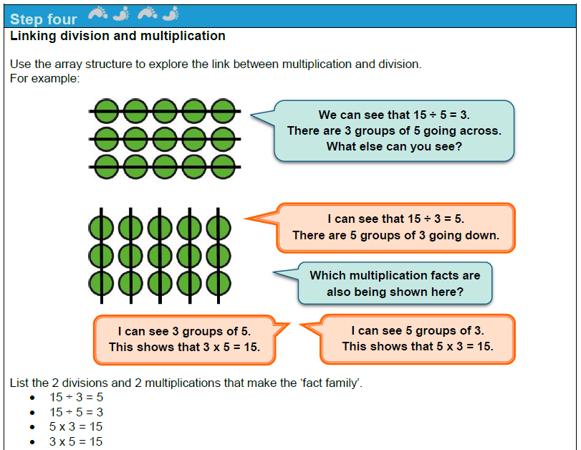

Pupils will draw arrays using multiples of 2, 5 or 10. e.g. 4 x 5 = 20.
Some pupils may need to use counters or other manipulatives to crate their array before recording it pictorially.
For each array, pupils should record the 2 division and 2 multiplication statements that are shown.

Mastery Activity
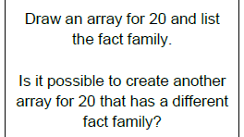

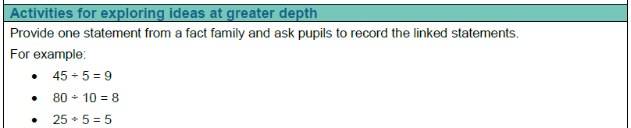

e.g. 5 x 5 = 25

