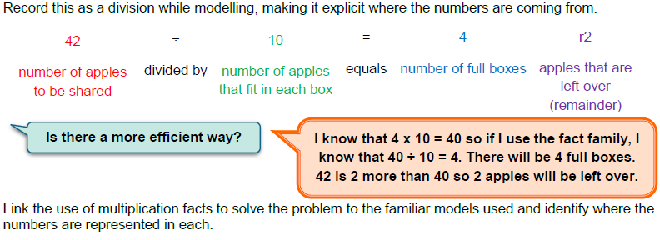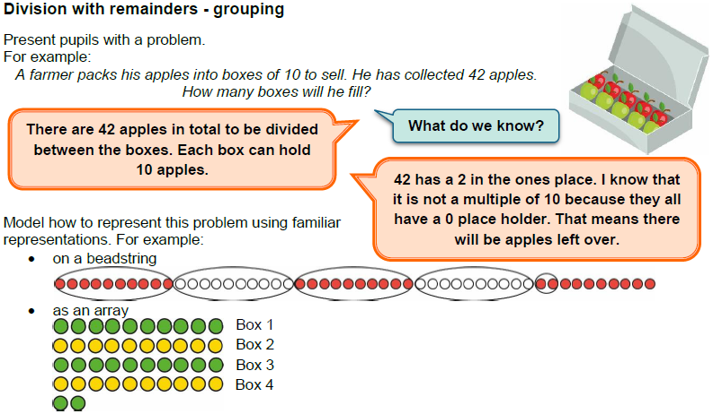

Pupils are to calculate divisions that will result in a remainder. Encourage the children to use the most efficient method they can.

Below are some example questions pupils could be given.

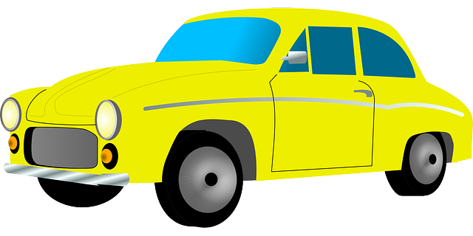

27 children are travelling to a house

party (all the restaurants are closed).

Each car can hold 4 children.

How many cars will be required?

There are 46 toilet rolls left in the

supermarket.

How many people will be able to

take 5 rolls?

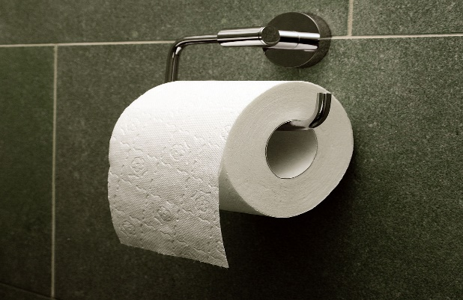

A shirt requires 10 buttons.

How many shirts will a factory

be able to make with 93

buttons?

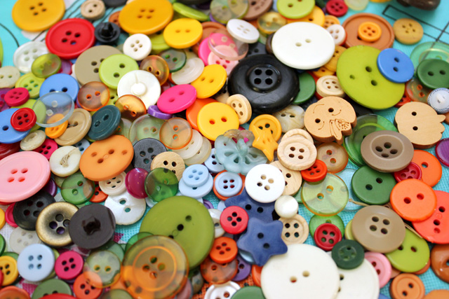

There are 17 shows to watch on my Netflix list.

If I watch 3 shows a day. How many days will it take to watch all the shows?

**Mastery Activity**

