Why is Easter important to Christians?
Activity 1
Children draw the bread and the wine and write the symbolism – the body and blood of Jesus.
Discuss Good Friday, after Jesus was arrested in the garden of Gethsemane.
The Resurrection
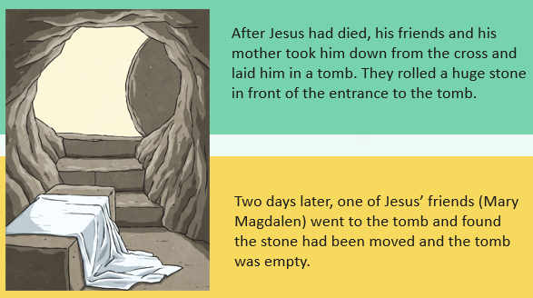
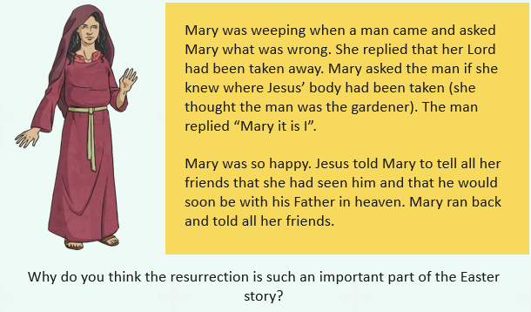
Explain that Good Friday is the most important day of the year for Christians – more so than Christmas, as without the Resurrection Jesus would simply have been just another good teacher.
Activity 2
Create a quiet, reflective space where children can produce their own drawings, poems, on the sadness of the crucifixion and the joy of the resurrection. Link to the Christian understanding of the Easter story and why it is important to Christians today.

