Answer Sheet: Science Assessment Year 2
Animals, including humans

question | answer | marks | notes
1. Write the numbers 1-6 in the boxes in the order from the youngest to oldest.
 | 1, 3, 5, 4, 6, 2 | 6 | 1 mark for every correct position.
2. Draw lines to show the three different life cycles
 | 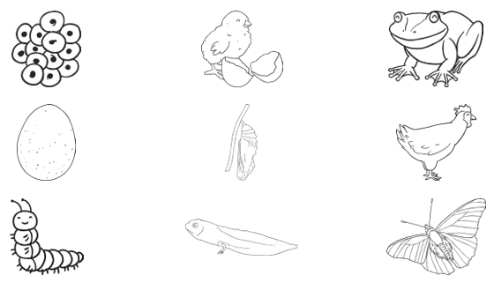 | 3 | 1 mark for every correct life cycle.
3. Sort the following animals into whether their mother gave birth to them or whether they laid an egg. Draw lines to the correct label.
 | mother laid an egg  snake, crocodile, fish  mother gave birth  dog, cow, horse | 6 | 1 mark for every correct answer.
4. Circle the three things that animals must have to grow and survive.
 | water food air | 3 | 1 mark for every correct answer.

