**Sort these into Living, Dead or Never Been Alive**

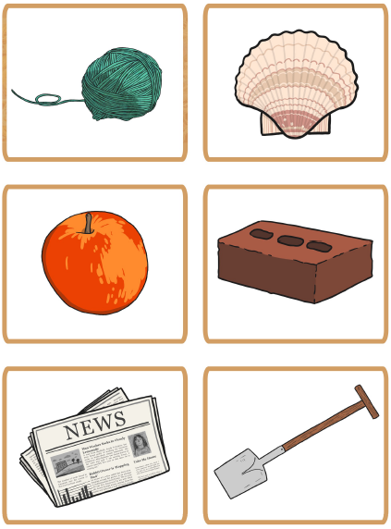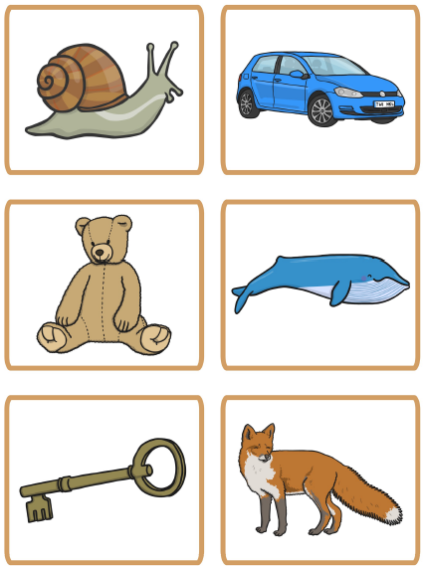

**If possible, have a look outside. Come up with 3 objects (1 alive, 1 dead and 1 that’s never**

**been alive. Draw the 3 items and give a reason as to how you know it’s either alive, dead**

**or has never been alive.**

Try and use ‘also’ ‘in addition’ ‘as well as this’ to give multiple reasons.

**Alive**

**I know this object is alive because…**

**Dead**

**I know this object is dead because…**

**Never been alive**

**I know this object is has never been alive because…**