Science – Producers and Consumers

Match up each of the key words and their definitions.
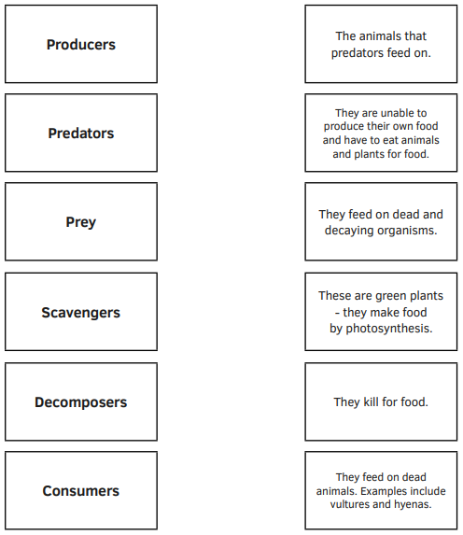
You could use an online dictionary to do this.

