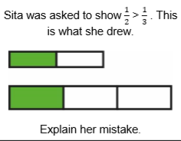
Answer: Sita was wrong because although the diagrams are drawn correctly, the two rectangles are not the same size

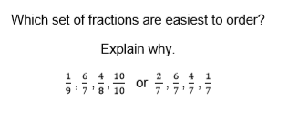
Answer: It is easier to order the fractions with the same denominator because they show equal parts of the same shape.

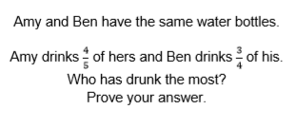
Answer
////////////////// | ////////////////// | ////////////////// | ///////////////////

//////////////////////// | /////////////////////// | ////////////////////////

Amy drank more as 4/5 is more than 3/4

