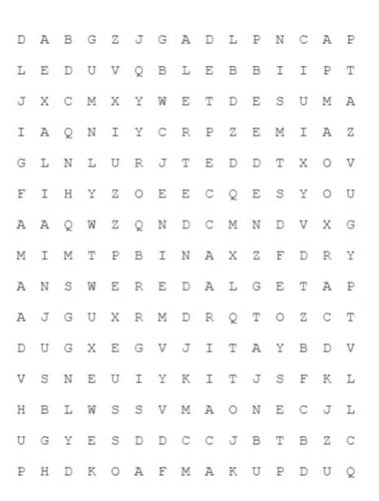

accepted

added

admired

announced

admitted

alerted

advised

amused

answered