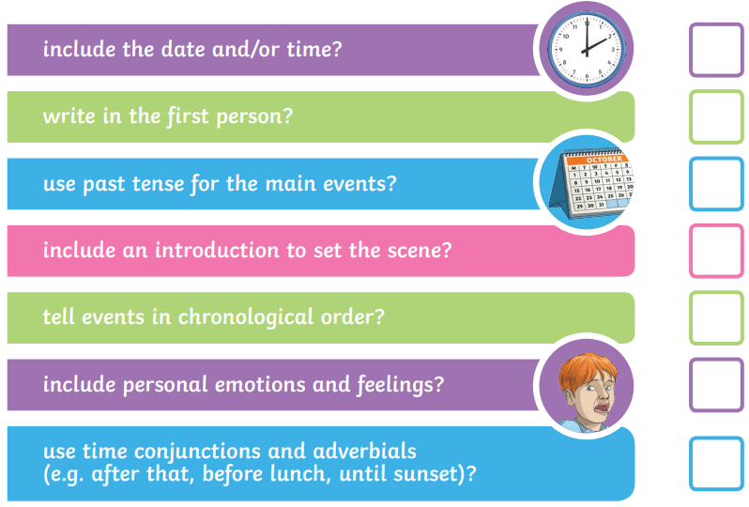
Year 2 - Instructions Checklist

