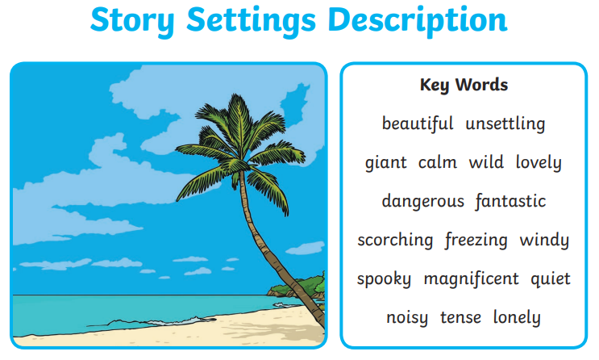

Write a paragraph describing this setting.

The beach is…

