Poetry and punctuation

Lesson 1

Last week we looked at constrained writing. Constrained writing is when limits are put on your writing, or you have a pattern you have to follow.

These next two poems each follow a different pattern. Can you find out what they are?
Hint: Look for rhyming scheme, syllables, alliteration. Annotate the poems marking down any patterns you can find. As a challenge can you discuss how the form of the poem helps the mood of the poem.

A flea and a fly in a flue*
Were imprisoned, so what could they do?
Said the fly, "let us flee!"
"Let us fly!" said the flea.
So they flew through a flaw in the flue.
—Ogden Nash
*Chimney

The House on the Hill
They are all gone away,
The House is shut and still,
There is nothing more to say.

Through broken walls and gray
The winds blow bleak and shrill:
They are all gone away.

Nor is there one to-day
To speak them good or ill:
There is nothing more to say.

Why is it then we stray
Around the sunken sill?
They are all gone away,

And our poor fancy-play
For them is wasted skill:
There is nothing more to say.

There is ruin and decay
In the House on the Hill:
They are all gone away,
There is nothing more to say.

Edward Arlington Robinson

Lesson 2

The first poem was an example of a limerick, and the second was an example of a villanelle. Each poem has their own rules here are two more examples (one a limerick and the other a villanelle). Which poem is more serious, and which one more comic? See if you can find out the rules for each poem. Look at line length, repetition and syllables.

Things that go 'bump' in the night
Should not really give one a fright.
It's the hole in each ear
That lets in the fear,
That, and the absence of light!

Spike Milligan

NIGHTMARES
I cannot sleep, the dreams around me crawl;
Beneath my bed what strange sounds I hear.
And the light switch is on the other wall.

Are these fears real? Or am I a fool?
Bogeys and ghosts are not to fear!
I cannot sleep, the dreams around me crawl.

I shan’t cry out to mum, nor call
I will be brave, I will take heart.
And the Light switch is on the other wall.

Will the monsters eat me? Will they maul?
What was that sound that makes me start?
I cannot sleep, the dreams around me crawl.

I bury my head in pillow and bawl,
Twisted shadows flit, dance and dart
And the light switch is on the other wall.

These monsters hidden in my mind they rule.
My resolve, dissolves and quickens the heart
I cannot sleep, the dreams around me crawl
And the light switch is on the other wall.

You should now have got some idea for the rules of each poem. They are both considering a similar theme. So now compare each poem, looking at how they have treated their theme differently.

Make a list of similarities and differences.
Here is a Haiku - what are the rules of this poem, and is similar or dissimilar to the two previous poems. Why ?

Fear keeps me from sleep
Who opened the wardrobe door?
Mum, Dad or Monster?

Lesson 3
Look at this picture try and create 2 poems, one has to be a limerick and the other has to have a structure of your own choosing. You don’t have to use a Villanelle (but you can challenge yourself). Choose instead from these styles: Rhyming couplets, acrostic or haiku

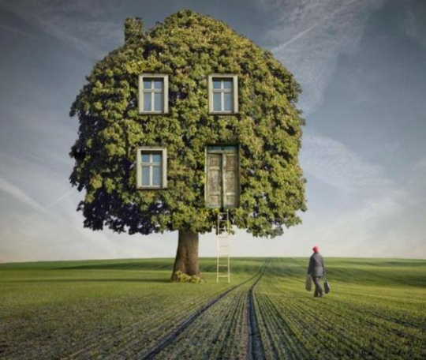

Lesson 4
Now take your best poem and roll a dice

1= a
2=e
3=o
4=o
5=e
6=a

Which ever number you land on will tell you what lipogram to re-write your poem as. Can you still keep to the same poetic rules as before?

Lesson 5
As it is Friday, it is time to publish and illustrate all your poems. Don’t forget to include an explanation of how you made them.

