Foundation Subjects:

Monday Science: Rotten Eggs and Rotten Teeth
What is the effect of different types of drinks on your teeth?.

Equipment:
Some eggshell,
A glass,
A selection of soft-drinks (e.g. cola, squash, a juice-drink, fresh fruit juice and water).
Instructions
Hang a bit of eggshell from a thread, and suspend it in a glass. Fill the glass with cola. Do the same in other glasses but with squash, juice-drink, fresh fruit juice and water.
Leave them for a week, then remove the eggshell fragments for comparison.

The cola shell will be soft to the touch, the squash and juice-drink shells will also be soft (although not necessarily as much) and the juice and water ones should be undamaged.

Now for the ‘yuk’ bit – the experiment would have had the same effect if you’d used human teeth instead of eggshells!
Try it, if you’re at the milk-teeth falling out stage (and willing to forgo a tooth-fairy visit for the sake of science), but eggshells are made of a similar material to teeth so make a great alternative.
This experiment was recommended to us by…
Remember BE SAFE: Any teeth will have to be sterilised before handling and make sure the eggshells are clean!

Measure the Magic:
What are the chemicals in the drinks? Research what goes into Cola and Squash.
Think if it can do that to a tooth or an eggshell what might it do to some soft tissue, like a stomach?

RESEARCH:
Look up the word Nutrients. Find out what would be the best type of food or drink to maintain healthy teeth.
Question: If a food or drink is good for your teeth does that automatically make it good for the rest of your body?
Last week we looked at the eye, what type of food might be good you keeping the eyes healthy.

Tuesday: RE
Meditation in Worship
The historical Buddha, Siddhãrta Gautama, taught a simple mindfulness practice:
“When walking, walk; when standing, stand; when sitting, sit; when lying down, lie down”.
He could as well have said “when drawing, draw”.
Mindful drawing is an embodied practice. In other words: bring yourself (your mind and your body) to the present moment and get immersed in the act of drawing without doing anything else simultaneously.
Instructions:

Drawing Mandalas
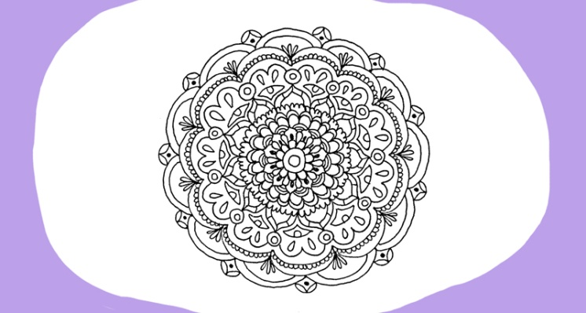

What is a mandala?
The word “mandala” comes from the Sanskrit for circle, and it also encompasses the ideas of wholeness and unity. Carl Jung is credited with using the mandala in therapy sessions—drawing mandalas can be a wonderful tool for emotional expression, self-soothing, and connection to inner calm.
Drawing mandalas is the most fun when you do it free hand.
The purpose of these exercises is to cultivate mindfulness, so we don’t care about perfection—all we care about is the process.
Here’s how to draw a mandala free hand:
- Start with the center. I recommend starting with a small circle or two.
- Start adding elements from the inside out. It’s easier to keep symmetry on a small scale, so by drawing layer by layer, you can keep your mandala balanced even without using a ruler or a compass.
- While you draw, try to focus your attention on the tip of the pen and the small part you’re currently drawing.
- Simultaneously, keep your awareness open to encompass the whole mandala—this will train you to draw more proportionately, as well as keep your attention to drift to unwanted thoughts.
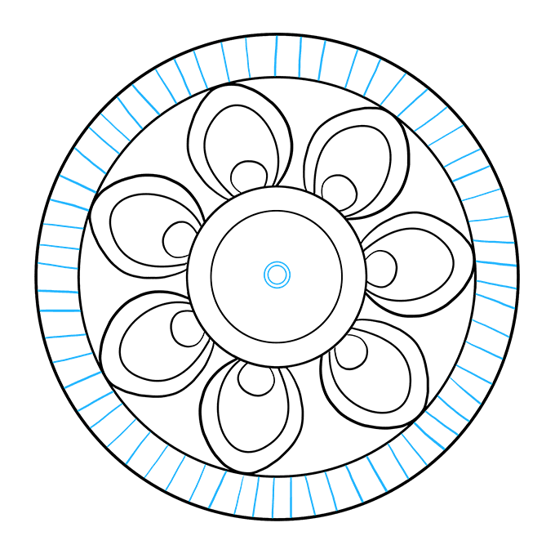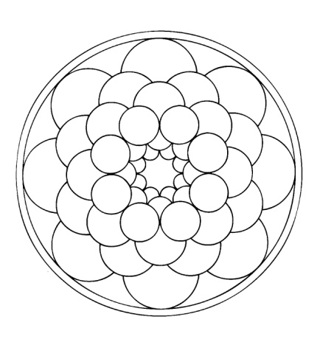

In Tibetan Buddhism, drawing mandalas is a form of prayer. In the end, whether it’s with mandalas, with drawing, or with any other activity in life, the results often matter less than the process: your state of mind, what you feel while you’re drawing, your intention, and the quality of your presence.
How do you feel? Has your mind cleared? Do you feel more relaxed?

Wednesday:
PSHE
Today we are going to think about how we contribute positively to those around us. How can we take responsibility for our actions and help those around us. Being helpful helps to spread happiness it also helps us to stay focused and productive.
- Draw a picture of your head.
- Outside your head make a list of the responsibilities that you have in the home.
- Inside the head make a note of how these responsibilities make you feel. For example one your responsibilities might be to keep your room tidy. It might feel like the worst job EVER!
- Now write out that list of responsibilities again, but this time think about all the positive outcomes from doing your tasks. For example:
I have a tidy room.
I can find everything I want
Nobody is nagging me
I have made people happy
I am proud of my work.
- Do the positive outcomes outweigh the negative ones?
- Take some time to think how you could be more helpful.

Thursday:
History
The History of London:
https://www.museumoflondon.org.uk/application/files/8015/1843/4079/PH_AngloSaxonsinLondon.pdf
INSTRUCTIONS:
We are going to continue with our history fact file of London:
Using the link above I want you to imagine you are an Anglo-Saxon merchant. You have arrived from Mercia to sell some wool in Lundenwic.
Using your 5 senses describe:
What you see
What you smell
How you feel
What you hear
What is it like to see so many people?
Research Anglo-Saxon names to give your story an authentic feel.

Friday:
ART/DT
Art and Poetry
A Humument has been a work in progress since 1966 when artist Tom Phillips set himself a task: to find a second-hand book for threepence and alter every page by painting, collage and cut-up techniques to create an entirely new version. The book he found was an 1892 Victorian obscurity A Human Document by W.H. Mallock and Phillips transformed it into A Humument. The first version was printed by the Tetrad press in 1973, and Phillips has continued to transform it, revise it and develop it ever since.
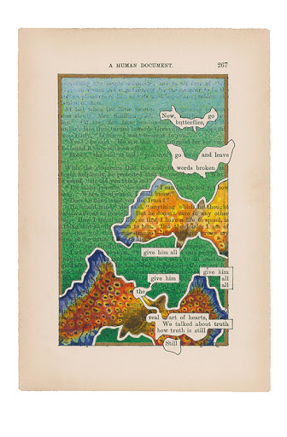
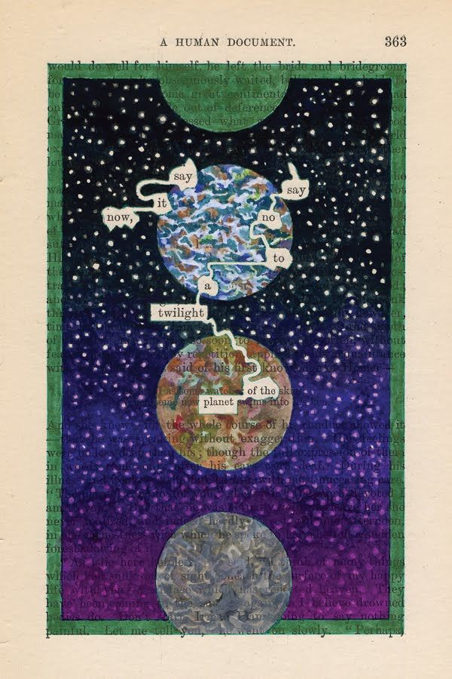
What Tom Phillips has done is to take a page, and paint a picture over it. However, he has left some works exposed to create some meaning for the piece.
Take a newspaper – ask first! Cut out a large piece of text, or if you can photocopy an unillustrated page from a novel.
Step 1: Scan the page first before reading it completely. Keep an eye out for an anchor word as you scan. An anchor word is one word on the page that stands out to you because it is packed and loaded with meaning and significance. Starting with an anchor word is important because it helps you to imagine possible themes and topics for your poem.
Step 2: Now read the page of text in its entirety. Use a pencil to lightly circle any words that connect to the anchor word and resonate with you. Resonant words might be expressive or evocative, but for whatever reason, these are the words on the page that stick with you. Avoid circling more than three words in a row.
Step 3: List all of the circled words on a separate piece of paper. List the words in the order that they appear on the page of text from top to bottom, left to right. The words you use for the final poem will remain in this order so it doesn’t confuse the reader.
Step 4: Select words, without changing their order on the list, and piece them together to create the lines of a poem. You can eliminate parts of words, especially any endings, if it helps to keep the meaning of the poem clear. Try different possibilities for your poem before selecting the lines for your final poem. If you are stuck during this step, return back to the original page of text. The right word you are searching for could be there waiting for you.
Step 5: Return to the page of text and circle only the words you selected for the final poem. Remember to also erase the circles around any words you will not be using.
Step 6: Add an illustration or design to the page of text that connects to your poem. Be very careful not to draw over the circled words you selected for your final poem!

