Friday
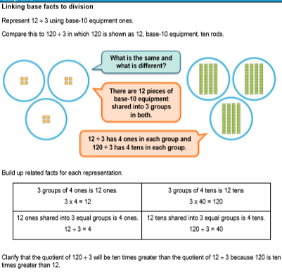

Worksheet
1. Following the above example, represent in base-10:

a) 15÷3
150÷3
b) 27÷3=
270÷3
c) 18÷3=
180÷3=
d) 16÷4=
160÷4=
e) 12÷4=
120÷4=

2. 240÷ ____=30
240÷ ____=40
320÷ ____=40
300÷ ____=50
640÷____=80
560÷ ____=80

3. Write a calculation in which the quotient is ten times greater than this calculation.
24÷3=8

4. Do 6÷3 and 60÷3 have the same answer? Use base-10 equipment to prove it.

Answers
Following the above example, represent in base-10:
1.
a) 15÷3=5 ….. ….. …..
150÷3=50 IIIII IIIII IIIII
b) 27÷3=9 ……… ……… ………
270÷3=90 IIIIIIIII IIIIIIIII IIIIIIIII
c) 18÷3=6
180÷3=60
d) 16÷4=4
160÷4=40
e) 12÷4=3
120÷4=30

2. 240÷ 8=30
240÷ 6=40
320÷ 8=40
300÷ 6=50
640÷8=80
560÷ 7=80

3. Write a calculation in which the quotient is ten times greater than this calculation.
24÷3=8 240$÷3=80$

4. Do 6÷3 and 60÷3 have the same answer? Use base-10 equipment to prove it.
NO.
6÷3=2 ..
60÷3=20 II

