Solve division problems

1. Complete the missing boxes:
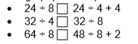
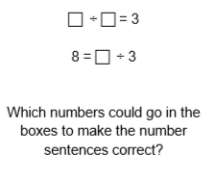
2.

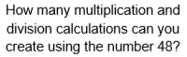
3.

Solve division problems

1. Complete the missing boxes:
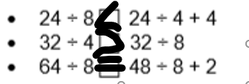
2.

3:1=3 8=24:3
6:2=3
9:3=3
12:4=3
..and so on..

3.

1x48=48 4x12=48 48:1=48 48:4=12 48:12=4
2x24=48 6x8=48 48:2=24 48:6=8 …and so on..
3x16=48 ..and so on.. 48:3=16 48:8=6

