This week your mission is to:
Multiply numbers up to 4 digits by a one- or two-digit number using a formal written method, including long multiplication for two-digit numbers Divide numbers up to 4 digits by one-digit numbers using the formal written method of short division and interpret remainders appropriately for the context Use rounding to check answers to calculations and determine, in the context of a problem, levels of accuracy.
Lesson 1: INTERPRETING REMAINDERS - Look at this problem, how is it solved?
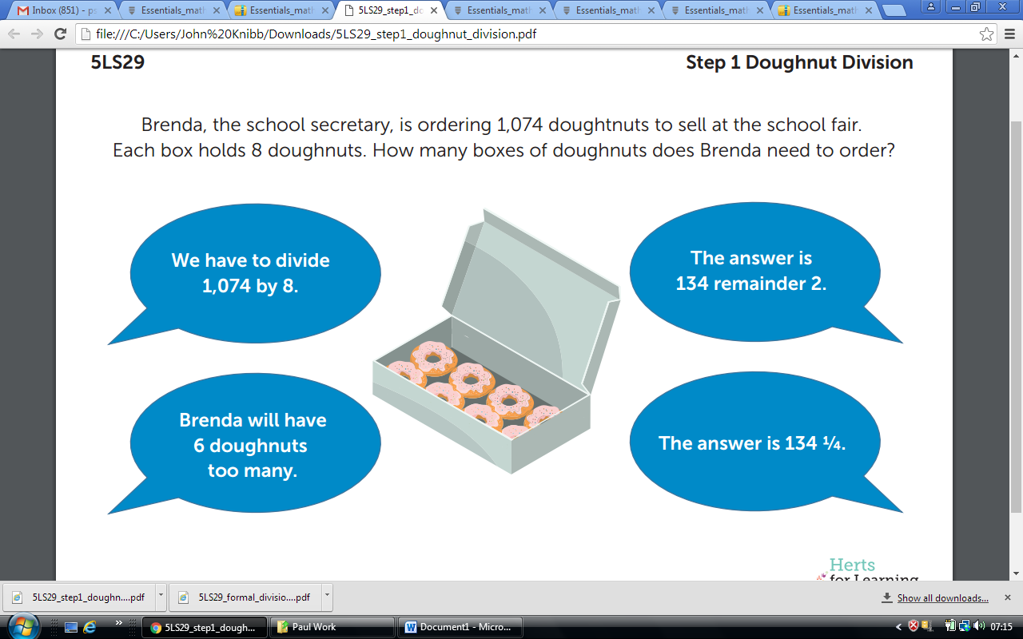

Questions | Answers
Is 134 remainder 2 the answer to the question? | 1,074 divided by 8 is 134 remainder 2, but it isn’t the answer to how many boxes she needs to order.  Take this away to see the answers.  (also at the end of the lesson – no peeking!)
Where has the fraction come from? | The remainder of 2 means that there are 2 out of the next group of 8. This can be written as 2/8 or ¼.
How many boxes does she need to order? | She needs to order 135, because 134 boxes won’t be enough.
Brenda will have 6 doughnuts to many. Is this correct? | Each box has 8 doughnuts. She needs 2 doughnuts from the last box to make 1,074. That’s what the remainder means. So, she has 6 of the 8 doughnuts in the last box left over. I could check by 134 x 8 = 1,072.

When we are dividing in the REAL WORLD, not the classroom it is important to consider what is the problem we are actually solving. In Brenda’s problem she had to know how many boxes of doughnuts she would need. Therefore, the answer is not 134 remainder 2, but 135. This is because the problem is one of how does she meet the supply of doughnuts, not what is 1074 divided by 8.
Have a look at this sorting frame. It is a process by which we can make sense of what the question is actually asking us to.

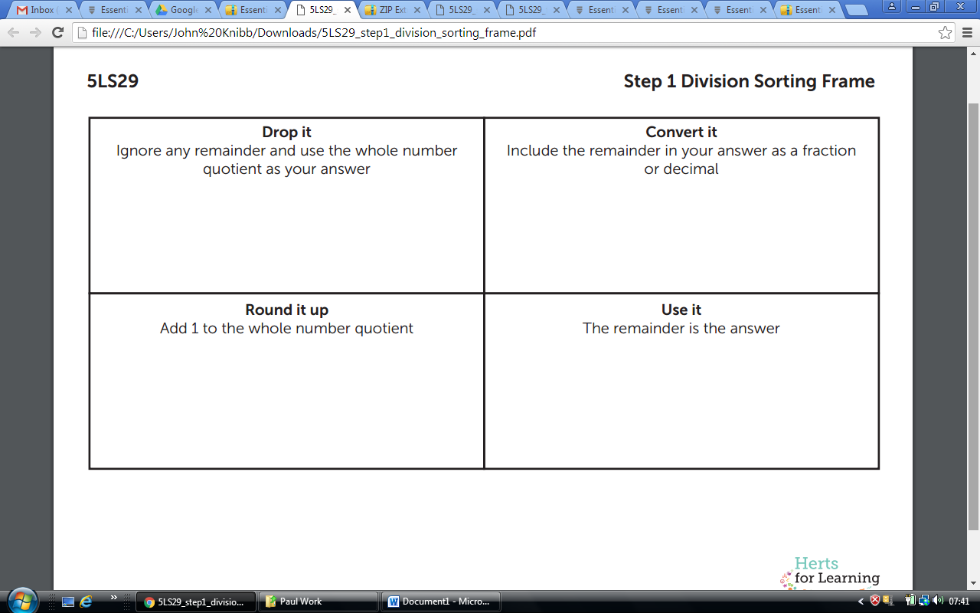
Using the frame above, how many different answers can you find for this?
400 ÷ 6
Now sort the questions into the categories below and use what you already know about 400 ÷ 6 to answer them. Think about how you have sorted the questions. Did all the questions have the same numerical answer? How did the question stem change your answer?
A doughnut box holds 6 doughnuts. A baker makes 400 doughnuts. How many boxes can she fill? | A doughnut box holds six doughnuts. How many boxes of doughnuts must a fast food restaurant buy to have 400 doughnuts?
There are 6 doughnuts per box. A baker makes 400 doughnuts. How many doughnuts will be in the last box? | A primary school buys 400 doughnuts to share equally amongst six classes. How many doughnuts does each class get?
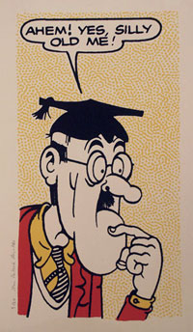
How can 400 ÷ 6 have so many answers? Surely there is only one answer?
Now solve 900 ÷ 8. Find the four different possible answers and how can you manage the remainder differently: Also consider when you would use the different possible answers.

What are the answers to these following questions, and into what part of the sorting frame to they fit?

- Charlie had 1230 leaflets to deliver. She bundled them in sevens. How many bundles of 7 did she have?

- Ms Rainbow has 770 colouring pencils. She wants to put an equal number of pencils on each table. She has 8 tables. How many pencils are left over as spares?

- Six children earned £585 washing cars. They want to share the money equally. How much do they each receive?

- A spoonful is 5ml. How many spoonfuls can you get from a bottle containing 1379 ml? How much will be left in the bottle?

- A box holds 6 pencils. How many boxes are needed to hold 1,550 pencils?

- Eggs are put in trays of 9. The trays are then packed into boxes. Each box contains 5,121 eggs. How many trays are in each box? How many eggs are in 23 boxes?

ANSWERS – I said NO peeking!

1,074 divided by 8 is 134 remainder 2, but it isn’t the answer to how many boxes she needs to order.
The remainder of 2 means that there are 2 out of the next group of 8. This can be written as 2/8 or ¼.
She needs to order 135, because 134 boxes won’t be enough.
Each box has 8 doughnuts. She needs 2 doughnuts from the last box to make 1,074. That’s what the remainder means. So, she has 6 of the 8 doughnuts in the last box left over. I could check by 134 x 8 = 1,072.

Lesson 2: Creating word problems involving different division contexts

In this lesson your parents or an older sibling will have to answer your questions. You are going to be the teacher.
First you need to create four different word problems for the calculation: 1,959 ÷ 6. The answers to the four different problems should be: a) 326 b) 327 c) 326 ½ d) 3
Use the sorting frame from yesterday’s lesson to help to create the question. Here is an example for you, what would the answer be?
Mabel has to buy 1959 Mcguffins for an unspecified reason, they come in boxes of 6. How many boxes does she need to buy?
This sheet should help you create your questions. You might need to copy it out yourself:
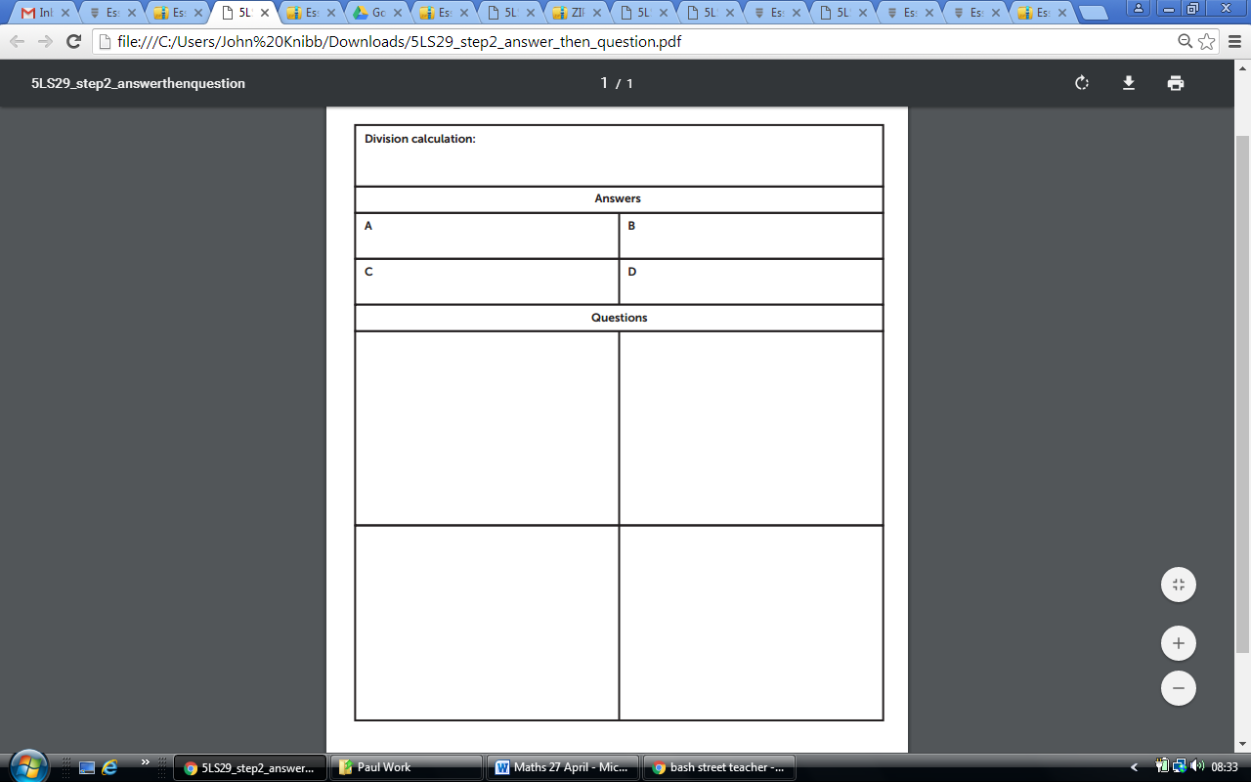
Give the questions to your parents or siblings. Ask them to create a word problem for one of the answers (crossing next to the answer to indicate that it has been used). They then return the sheets to you who will then check that the questions are all correct.
You should now have 8 questions and answers. The questions and answers can now be cut up and used to create a set of ‘match up’ cards - answers have to be matched to questions.
- Ben’s book is 457 pages long. He reads 7 pages a day. How many days will it take Ben to read his book? How many pages will he read on the last day?

- Look at the statement what is the correct answer and why?
Always, Sometimes, Never: When solving a division problem the quotient is always the answer to the question.
- Eight people share the cost of a trekking holiday equally. The total cost of the holiday was £6,850. How much does each person pay?

Lesson 3: Applying formal multiplication to solve problems

First we are going to play this game it does require 2 players, (you may have to copy the board yourself) so grab a parent or older sibling if you can. If you can’t you have to play against yourself – at least you will win!

How to play:
• Each player or team takes it in turns to select one number from a pink flower and one from a blue flower and multiplies them together. The player or team then cover any single hexagon that matches their product with their counter.
• If on their turn, the product does not match any of available hexagons, the player cannot place a counter. Play is passed to the next player.

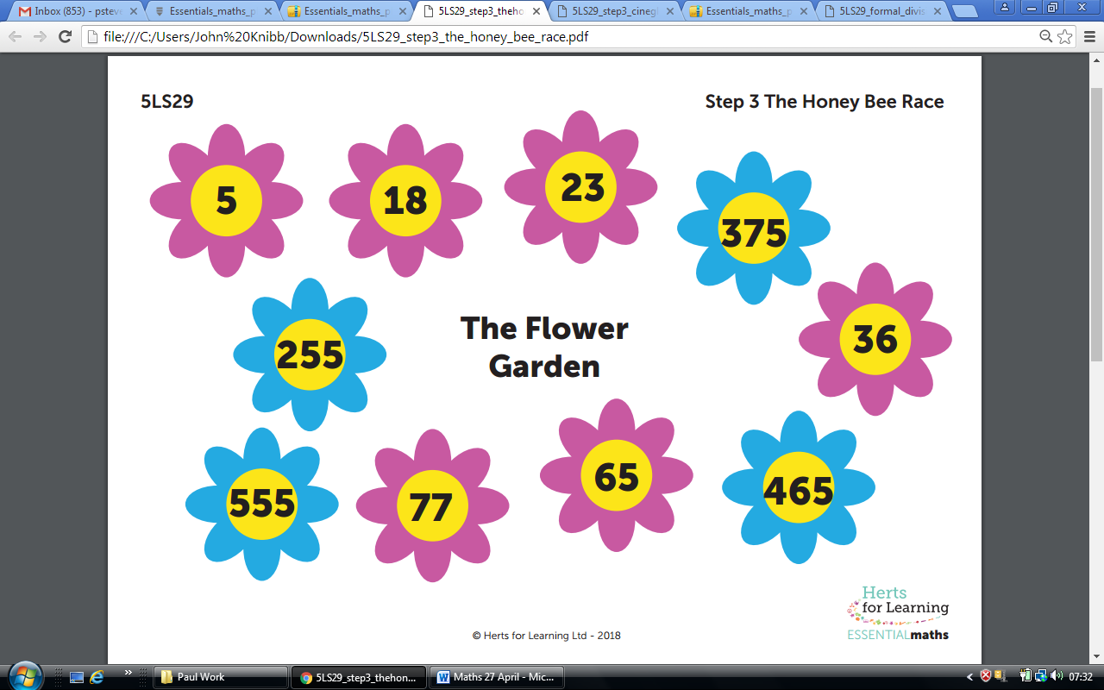
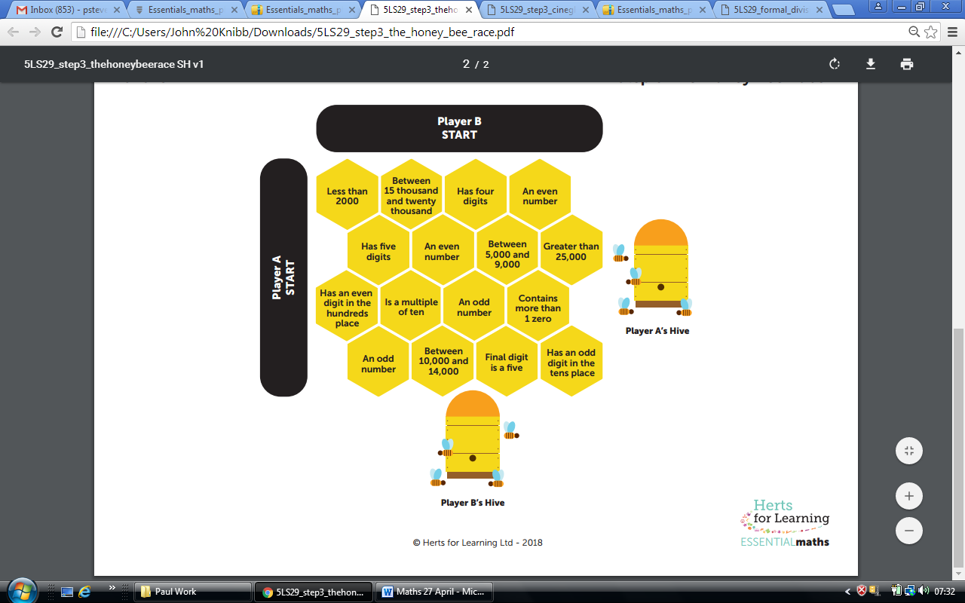

Now answer this question:

??? x ?? ≈ 6500 What could the two numbers be?

Look at this information for the cinema:

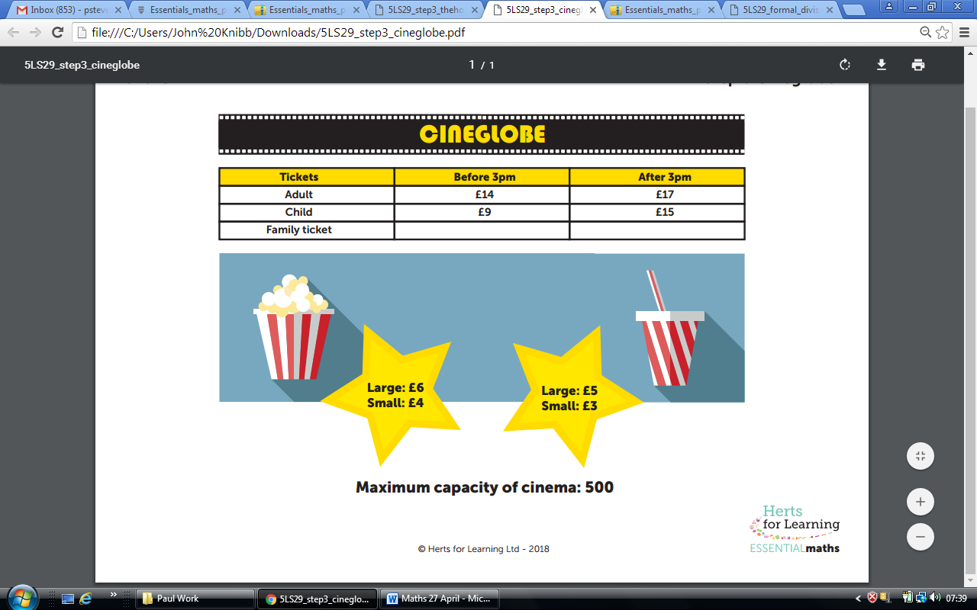

- What is the greatest amount of money that Cineglobe could collect at: - an evening performance? - an afternoon performance?

- For every 3 children attending the afternoon performance, 2 adults also attend. If Cineglobe is full, how much money has Cineglobe collected?

- The cinema is sold out. Three quarters of the audience are adults. 52 large bags of popcorn were sold and 69 soft drinks. How much money did Cineglobe take?

- Design a family ticket for Cineglobe. What do you think it should cost? Explain how you think this would change the revenue Cineglobe collects at a children’s movie.

Lesson 4: Applying formal multiplication to solve problems.

Try this problem.

There are 12 stickers per packet.
There are 320 packets per tray.
The trays are then packed into boxes.
Each box contains 7 trays.
How many stickers are in each box?

Use the statement below and two standard dice as a starting point for exploration.
To play:
• Roll the two dice three times to create three, two-digit numbers.
• Place the two-digit numbers in any order in the statements below.
If you want to have the largest number of stickers in the box, does it matter where you place your two-digit numbers? Prove it.

Number of stickers in a pack:
Number of packs per tray:
Number of trays per box:
How many stickers are in the box?

Lesson 5: Investigation
https://nrich.maths.org/1783
Use the link above to help you in this investigation if you need it
I'm thinking of a number.
My number is both a multiple of 5 and a multiple of 6.
What could my number be?
What else could it be?
What is the smallest number it could be?
I'm thinking of a number.
My number is a multiple of 4, 5 and 6.
What could my number be?
What else could it be?
What is the smallest number it could be?
Here are some more questions you might like to consider:
I'm thinking of a number that is 1 more than a multiple of 7.
My friend is thinking of a number that is 1 more than a multiple of 4.
Could we be thinking of the same number?
I'm thinking of a number that is 3 more than a multiple of 5.
My friend is thinking of a number that is 8 more than a multiple of 10.
Could we be thinking of the same number?
I'm thinking of a number that is 3 more than a multiple of 6.
My friend is thinking of a number that is 2 more than a multiple of 4.
Could we be thinking of the same number?
Here's a challenging extension:
We know that
When 59 is divided by 5, the remainder is 4
When 59 is divided by 4, the remainder is 3
When 59 is divided by 3, the remainder is 2
When 59 is divided by 2, the remainder is 1
Can you find a number with the property that when it is divided by each of the numbers 2 to 10, the remainder is always one less than the number it is has been divided by?
Can you find the smallest number that satisfies this condition?

Yes, strange as it seems, Maths is actually useful and real people use maths everyday - it wasn’t just invented by teachers.
If you don’t think they work hard enough, or answer your questions well enough you can make them write out “I must work harder” a 1000 times.
A quotient is the quantity produced by the division of two numbers. EXAMPLE: 12 ÷3 = 4. 4 is the quotient.
If you don’t have any dice just think of 3 random numbers between 11 and 66.

