Maths

ANSWERS

Area, Perimeter and Compound shapes

Lesson 1: Perimeter

6m

L

4m

Look at the rectangle above, what can you say about the shape?

What do the two measurements help you to do?

Find area and find perimeter

How can you calculate the area of the shape? 4x 6

How can you calculate the perimeter of the shape? See below

What is the difference between area and perimeter?

Area is how much space the object takes up

Perimeter is the how long the edge is

There are two ways to calculate perimeter, can you work out both ways?[1]

Which way is most efficient and why?

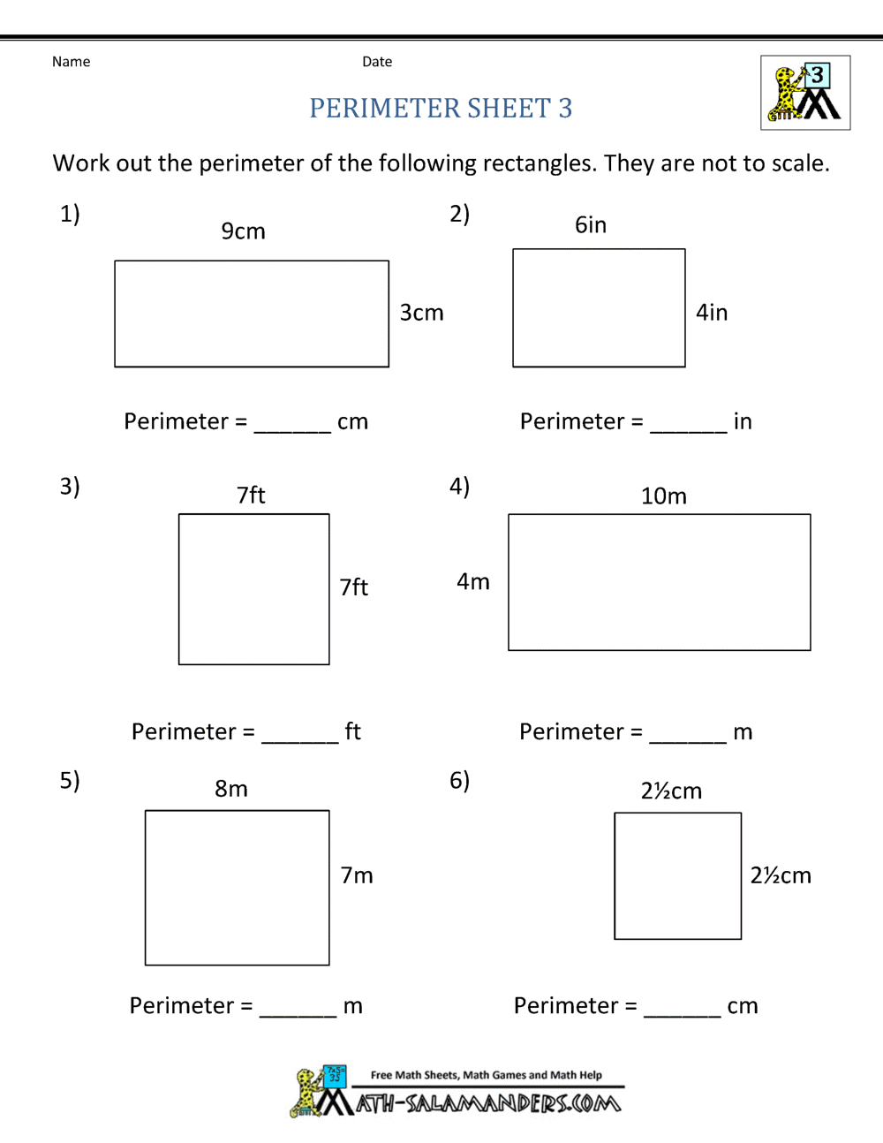

1. 24cm

2. 20in

3. 28ft

4. 28m

5. 30m

6 10 cm

***Challenge: Using a measuring tool (ie ruler or tape) find some rectangles to measure around the house working out the perimeter.***

Lesson 2: Area:

You will need some lollipop sticks, cotton buds, pencils or pens for this lesson.

[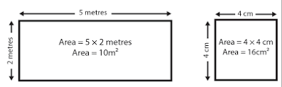](https://www.skillsyouneed.com/num/area.html?sa=X&ved=2ahUKEwiDocO-zOzoAhW0oFwKHYsXBBIQ9QF6BAgHEAI)

To find the area of a rectangle multiply its height by its width. For a square you only need to find the length of one of the sides (as each side is the same length) and then multiply this by itself to find the area. This is the same as saying length2 or length squared.

First make a rectangle using six lollipop sticks like this:

Measure the sides, now what is the area of the shape?

Now make a second shape only using four *different* lollipop sticks.

What is the area of this shape?

Now what happens if we put the shapes together like this:

This is now a compound shape, or a shape made from two or more shapes put together.

Let’s say that the 1st shape had an area of 16cm and the second shape had an area of 8cm. What is the area of the new shape?

To work out a compound shape we have to split the shape in to different shapes, so we can then work out the area of each shape and then fit them together.

Split these compound shapes into different shapes and work out the areas.

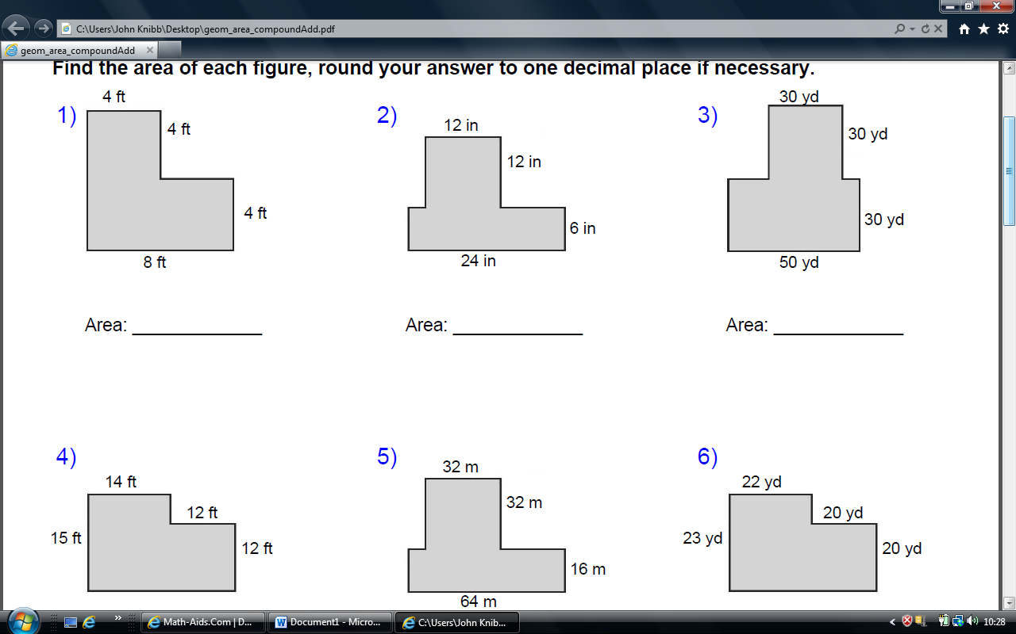

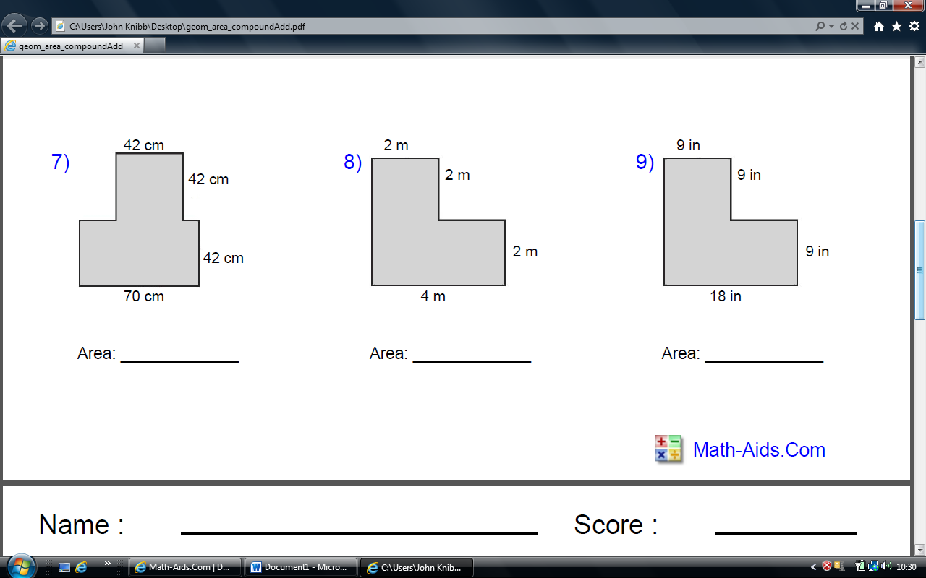

L

AREA THEN PERIMETER

1. 48ft/32ft

2. 168in/73in

3. 2400yd/220yd

4. 378ft/81ft

5. 2048m/224m

6. 906yd/129yd

7. 4704m/308m

8. 12m/16m

9. 243/72in

Lesson 3: Compound shape Perimeter

8ft



16ft

4ft

8ft

To work out the shape above we have to do the following things:

1. Split it in to two shapes



1. Work out the perimeter of shape A (only three sides, why?) 8+8+8 =24ft
2. Work out the perimeter of shape B 16 – 8 = 8 + 4+4+16 = 32ft (Why did I take 8 from 16 at the beginning?)
3. 24 + 32 = 56ft

Using the same compound shapes as yesterday work out the perimeters. Some are easier than others.

Which ones were more problematic and why? What did you need to do to work out the trickier perimeters?

Lesson 4:

Either

go to <https://www.math-aids.com/Geometry/Perimeter/Compound_Shapes_Area_Adding.html>

To generate your own worksheet – don’t forget to work out the perimeters as well

Or using a ruler draw 10 of your own compound shapes, making them more and more complex each time.

Lesson 5:

INVESTIGATION:

Nine squares with side lengths 1,4,7,8,9,10,14,15and 18 cm can be fitted together with no gaps and no overlaps, to form a rectangle.

What are the dimensions area and perimeter of the rectangle?

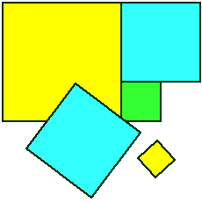

Here is what Ella from Neil Cummins school in the USA  wrote:

I figured out the problem by first finding the area of all of the squares. Once I figured out the area of the squares, I added all of the areas together.  At first I got 956 for the area, but when Mr. Owens showed us what other students had done, the right answer for the area was shown on the screen.  It turned out that I had forgotten to add in the area of the 10 by 10 square (100).   
  
I then figured out that you have to find all of the factors for the total area.  Mr. Owens showed us all of the factors for 1056, which is the total area.  He also mentioned that the sides of the rectangle could be bigger than 18  (which is the dimensions of the biggest square).  I tried dividing that by 18, but the answer turned out to be 58 r 12.  After I had listed them down, I thought that 32 x 33 would be the most likely of all.  I then drew a rectangle with those dimensions, and tried experimenting.  At first, I wasn't sure where to put the 18 square, but my friends Dakota and Hannah suggested that I put it in a corner.  So I started by putting the 18 square in the top left corner.  Since 18 + 18 is 36, I knew that 18 + 14 is 32.  Therefore, underneath the 18 square, I put the 14 square.  I put the 4 square right underneath the 18 square on the right side.  Then, since 4 + 10 is 14, I added the 10 square right underneath it.  I realised that the 9 square could fit beside the 10 square, so I put it there.  I made a mistake at first and made the dimensions of the 9 square 9 by 10.  Since it looked equal, I thought I was on to something.  After that, I tried to put the 15 square on top of the 10 square, but I knew it wouldn't work.  So then I tried the 7 square.  It fitted well, and there were 15 squares left on top of it.  There were 8 squares left over.  It was perfect for the 8.  But, I realised that the 8 was a square taller than the 7.  That was when I figured out that I had made a mistake.  So I corrected the 9 and 8 squares, and found the perfect spots for the 15 and 1 squares.  Then, I realised that it all fited!  
  
Here's the result:

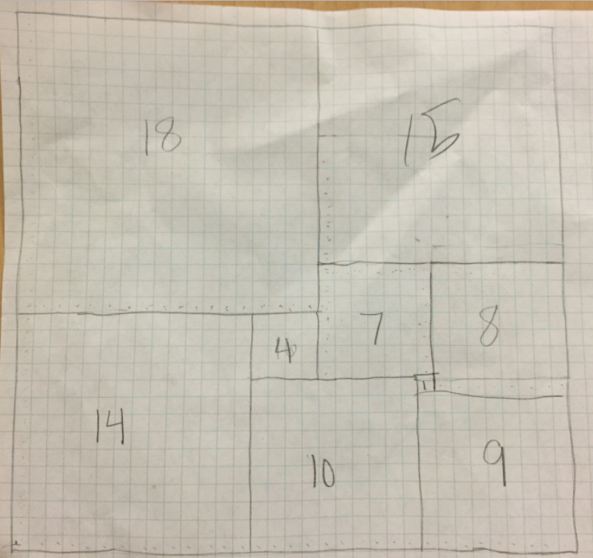

1. 6m + 6m + 4m + 4m

   (6m x 2) + (4m x 2)