Monday

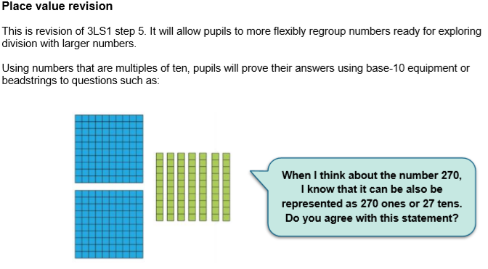

Can you regroup the following numbers in 2 different ways each? (You can also show your representation in base-10, as shown above)
e.g. 327 : 3 hundreds, 2 tens and 7 ones
32 tens and 7 ones
a) 528
b) 456
c) 111
d) 732
e) 921
f) 201
g) 445
h) 903
i)764
Answers:
a) 528: 5 hundreds, 2 tens, 8 ones

II ……..
52 tens, 8 ones
528 ones
b) 456: 4 hundreds, 5 tens, 6 ones
45 tens, 6 ones
c) 111: 1 hundred, 1 ten, 1 one
11 tens, 1 one
d) 732: 7 hundreds, 3 tens, 2 ones
73 hundreds, 2 ones
e) 921: 9 hundreds, 2 tens, 1 one
92 tens, 1 one
f) 201: 2 hundreds, 0 tens, 1 one
20 tens, 1 one
g) 445: 4 hundreds, 4 tens, 5 ones
44 tens, 5 ones
h) 903: 9 hundreds, 0 tens, 3 ones
90 tens, 3 ones
i) 764: 7 hundreds, 6 tens, 4 ones
76 tens, 4 ones
On your challenge worksheet, after you complete one of the challenges (*, ** or ***), try and regroup your numbers as above.

