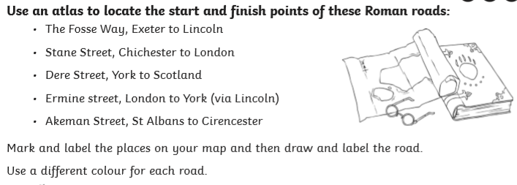

If you can not print the worksheet provided, draw the UK map in your book, locate the important cities and then draw and label the above roads.

