Division by grouping
Example:
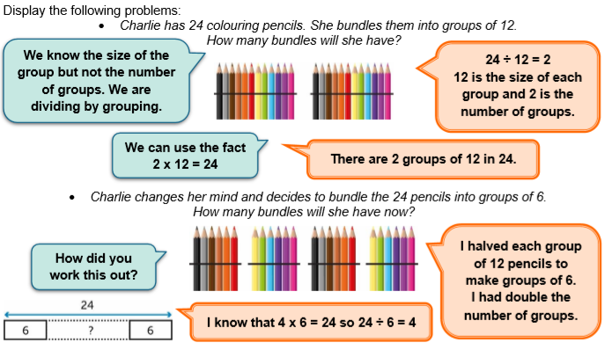

Worksheet
1. Millie says she would prefer the 24 pencils to be bundled into groups of 3. How many bundles would Millie have then?
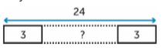
2. Mr. Jeffrey collets stamps. He has 32 to stick in his album. He sticks 8 onto each page. How many pages does he use?
3. A pet shop has a delivery of 36 chinchillas. They put 3 into each cage. How many cages to they need?
Challenge:
Worksheet - Answers
1. Millie says she would prefer the 24 pencils to be bundled into groups of 3. How many bundles would Millie have then?
24:3=8 bundles
2. Mr. Jeffrey collets stamps. He has 32 to stick in his album. He sticks 8 onto each page. How many pages does he use?
32:8= 4 pages
3. A pet shop has a delivery of 36 chinchillas. They put 3 into each cage. How many cages to they need?
36:3=12 cages
Challenge:
Answer 1: 3x3=9
23-9=14
14:2=7 (7 bicycles and 3 tricycles)
Answer 2: 5x3=15
23-15=8
8:2=4 ( 4 bicycles and 5 tricycles)

