Thursday
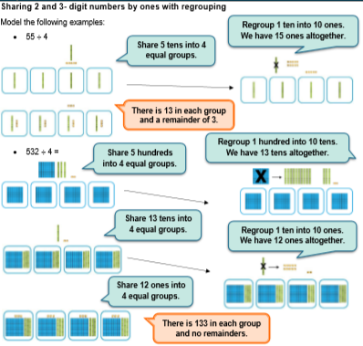

Worksheet
(If needed, draw as above in base-10 all the steps of your division)
a) 56÷4=
b) 92÷4=
c) 65÷4=
d) 44÷3=
e) 75÷3=
f) 423÷3=
g) 744÷3=
h) 956÷4=
i) 564÷4=
j) 649÷4=
k) 742÷3=

Challenge:
Write division calculations for the following rules:
1. The quotient (answer) below 20
2. The quotient (answer) must have 5 tens.
3. Answer must have a remainder of 2.

Answers
a) 56÷4 5 tens÷4=1r1 ten
We regroup 1 ten into 10 ones and add the 6 ones 16÷4=4
56÷4=14
b) 92÷4 9 tens÷4=2 tens r 1 ten
We regroup 1 ten into 10 ones
12÷4=3
92÷4=23
c) 65÷4 6 tens÷4=1 ten r 2tens
We regroup 2 tens into 20 ones
25÷4=6r1
65÷4=16r1
d) 44÷3 4 tens÷3=1ten r 1ten
We regroup 1 ten into 10 ones 14÷3=4r2
44÷3=14r2
e) 75÷3 7 tens÷3=2r1 ten 15÷3=5 75÷3=25
f) 423÷3 4 hundreds÷3=1hundred r 1hundred
We regroup 1 hundred into 10 tens
12 tens÷3=4 tens
3÷3=1
423÷3=141
g) 744÷3 7 hundreds÷3=2hundreds r 1 hundred
We regroup 1 hundred into 10 tens
14 tens÷3=4 tens r 2 tens
We regroup the 2 tens into 20 ones
24÷3=8
744÷3=248

h) 956÷4 9 hundreds÷4=2 hundreds r1 hundred
Regroup 1 hundred into 10 tens
15 tens ÷ 4= 3 tens r 3 tens
Regroup 3 tens into 30 ones
36÷4=9
956÷4=239
i) 564÷4 5 hundreds÷4=1hundred r1 hundred
16 tens÷ 4=4 tens
4 ones ÷4=1 one
564÷4= 141
j) 649÷4 6 hudreds÷4=1 hundred r 2 hundreds
24 tens÷4=6 tens
9 ones ÷4= 2 r1
649÷4= 162r1
k) 742÷3 7 hundeds÷3= 2hundreds r 1hundred
14 tens÷3= 4 tens r 2 tens
22 ones ÷3= 7 ones r 1 one
742÷3=247 r1

