Division by sharing

EXAMPLE 1

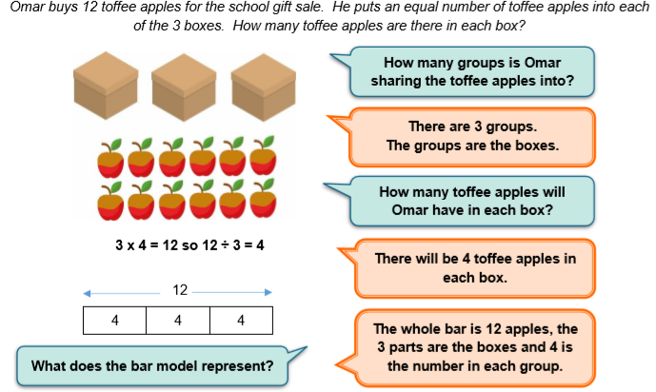

EXAMPLE 2

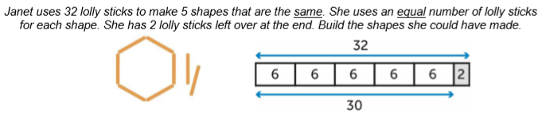

Worksheet
1.
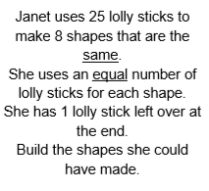
2.

3.

Now play The Remainder Game with someone in your family.

Worksheet - Answers
1.
25÷8= 3 r 1

2.
32÷8=4
3.
36÷9=4
Now play The Remainder Game with someone in your family.

