Division by sharing – Comparison problems

EXAMPLE:
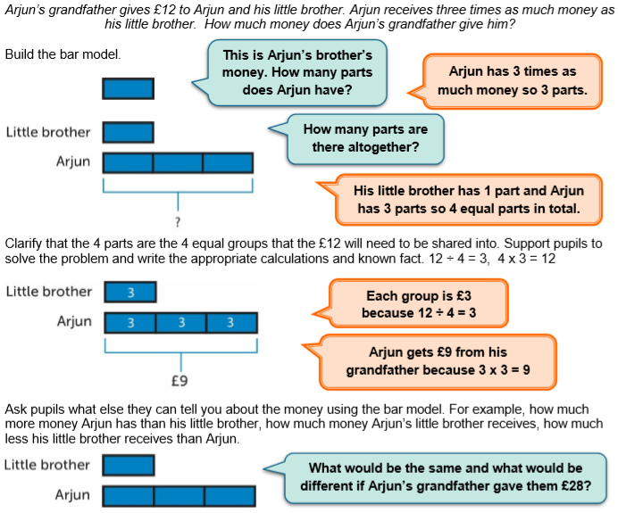

Worksheet
Using the same reasoning as above, solve these problems:
1. Arjun’s grandfather gives £28 to Arjun and his little brother. Arjun receives 3 times as much money as his little brother. How much money does Arjun get?

2. Arjun’s grandfather give £12 to Arjun and his little brother. Arjun receives 2 times as much money as his little brother. How much money does Arjun get?

3. At the school fair Mrs. Smith sells 4 times as much lemonade as her husband. Altogether they sell 20 litres of lemonade. How much more lemonade does Mrs. Smith sell than her husband?

Challenge:
Write 2 word problems using this model:

Worksheet - Answers
Using the same reasoning as above, solve these problems:
1. Arjun’s grandfather gives £28 to Arjun and his little brother. Arjun receives 3 times as much money as his little brother. How much money does Arjun get?
Arjun
His brother
3+1=4
28:4=£7 (His little brother)
7x3= £21 (Arjun)

2. Arjun’s grandfather give £12 to Arjun and his little brother. Arjun receives 2 times as much money as his little brother. How much money does Arjun get?
Arjun
His brother
2+1=3
£12:3=£4 (his brother)
£4 x 2= £8 (Arjun)

3. At the school fair Mrs. Smith sells 4 times as much lemonade as her husband. Altogether they sell 20 litres of lemonade. How much more lemonade does Mrs. Smith sell than her husband?

Mrs. Smith
Mr. Smith
4+1=5
20 : 5 = 4 l (sells Mrs. Smith)
4x4= 16 l (sells Mrs. Smith)
16-4= 12 l (more sells Mrs. Smith than Mr. Smith)

